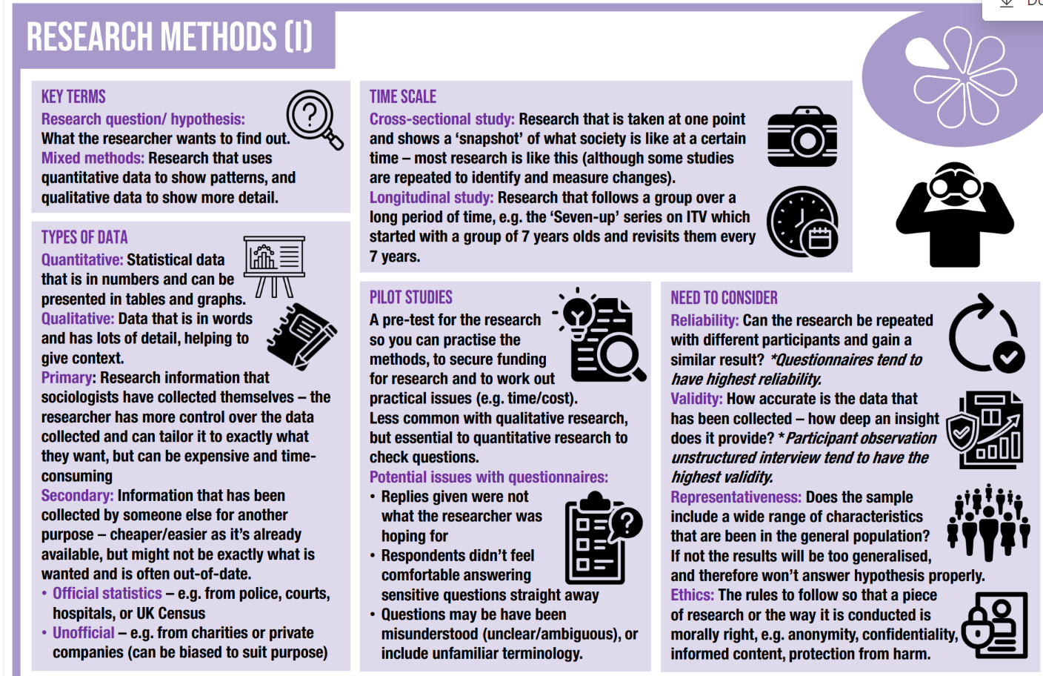
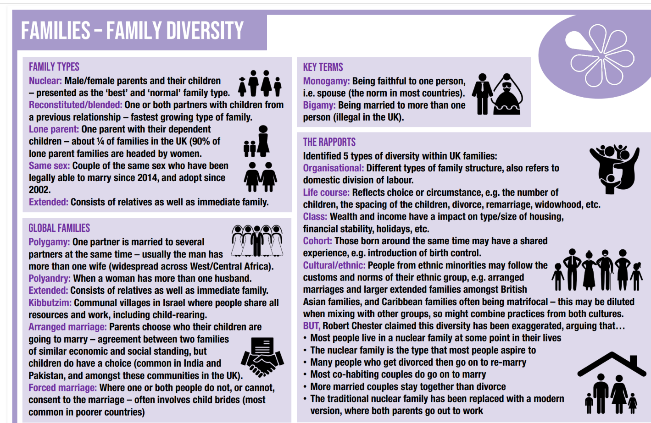
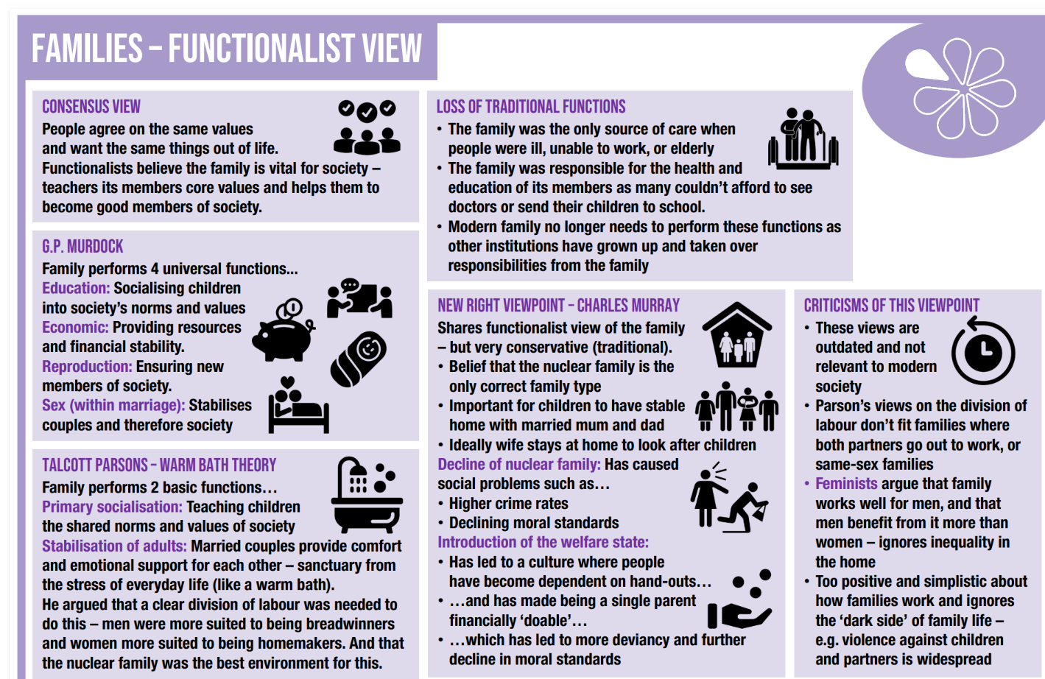
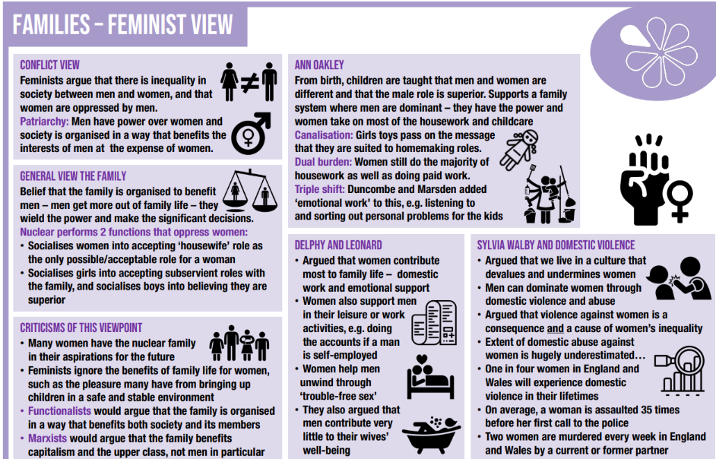
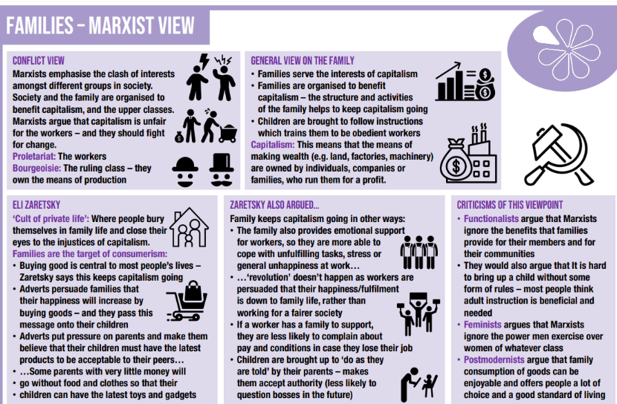
Aqa Sociology: Past Papers can be accessed here:
https://www.aqa.org.uk/subjects/sociology/gcse/sociology-8192/assessment-resources
Paper 1: The Sociology of Families and Education. Only complete the Families Section.

