[www.corbettmaths.com](http://www.corbettmaths.com)

Go to the website. It can be used on any device. This is intended to help you revise for your exams after your amazing start to the year. Go to the section pictured below which will give you all the video tutorials as well as worksheets and their answers. Have fun!

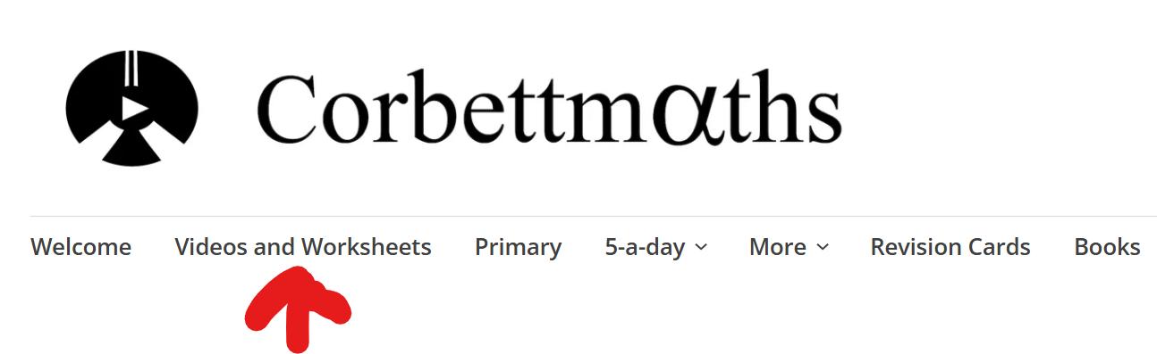

**Area**

Video 40, 41, 42, 43, 44, 45, 46, 47, 48, 49

**Surface area**

Video 310

**Perimeter**

Video 241, 242, 243

**Index laws**

Video 172, 174

**Metric units**

Video 349a, 349b, 349c

**Factors, multiples and primes**

Video 216, 218, 219, 220

**Inequalities**

Video 176, 177