Part B: Review of outcomes in the previous academic year

Pupil premium strategy outcomes
This details the impact that our pupil premium activity had on pupils in the 2021 to 2022 academic year.
Due to COVID-19, performance measures have not been published for 2020 to 2021, and 2020 to 2021 results will not be used to hold schools to account. Given this, please point to any other pupil evaluations undertaken during the 2020 to 2021 academic year, for example, standardised teacher administered tests or diagnostic assessments such as rubrics or scales.
If last year marked the end of a previous pupil premium strategy plan, what is your assessment of how successfully the intended outcomes of that plan were met?

Teaching (for example, CPD, recruitment and retention)
Activity/  Challenge | Impact of this approach | Actual Spend
Ensure that all children have access to high quality and age appropriate sex and relationships education utilising the Jigsaw PSHE/RSE Programme. PSHE RSE resources. PSHE coordinator role. | PSHE – Ofsted October 2021 commented on strength of provision. All statutory requirements being met.  Reporting system now set up and in use specifically for of HSB.  Sexions training for pupils on consent and appropriate sexual conduct.  PSHCE coordinator assigned for a year who over saw the implementation (insert cost and %). PSHCE coordinator assigned for this year too. | £4762  £2979
Providing resources to develop, embed and maintain the coaching time reading programme.  Support from the National Literacy Trust | 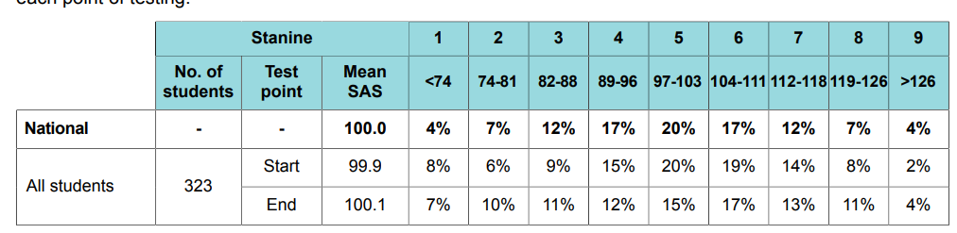  Year 7 Mild growth in average reading age over 4 months (99.9 to 100.1, 63% $≥97$at start verses 65% at end point.  When broken down by FSM, differences emerge. Non PP 0.7 gain verses PP 0.6 loss. Approx difference of 5 at both start and end point.  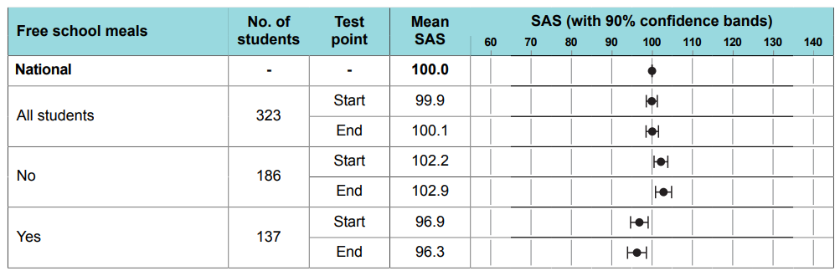  Ofsted Oct 2021 “Leaders have prioritised literacy and reading for all pupils. Pupils receive support from English intervention teachers to help them become more fluent readers. Teachers ensure that pupils experience a wide range of authors, cultures and styles of text. There are planned reading opportunities on Thursday afternoons. The reading curriculum is in the early stages of implementation.”  Tutor time reading using culturally diverse books chosen to meet the cultural capital agenda. | £13,000  £4964
Literacy catch-up small group work | Standardised GL tests info above. Summary below. Work done with intervention intervention assistant based on the below.  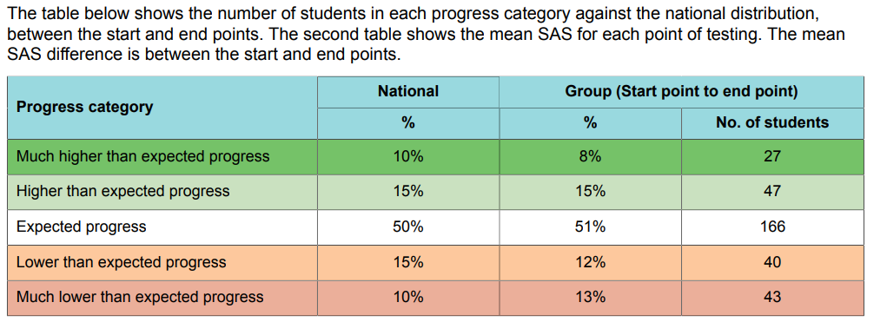
Purchase of standardised diagnostic assessments. Engage in trust wide standardised assessment. Training provided for staff to ensure assessments are interpreted correctly and outcomes acted on. | Standardised GL tests, reading age tests used, see results above.  Movement towards standardised assessments across the trust. Year 9 was end of year was standardised across the trust.  Mocks will be standardised trust wide this year beginning Nov 22. | £3000
Improving literacy in all subject areas in line with recommendations in the EEF Improving Literacy in Secondary Schools guidance.  We will fund professional development and instructional coaching focussed on each teacher’s subject area. It will be rolled out first in maths to help raise maths attainment for disadvantaged pupils, followed by subjects identified as priorities. | Reading interventions that took place this year include first story, catch up reading, book club, DEAL/R. All KS3 students have a reading book each day, there are weekly library lessons during English.  Staffing restraints have meant this couldn’t happen this year – will be rolled over to 22-23. | £3465
Embedding instructional coaching as the key mechanism for improvement in teaching and learning, including teacher release time, working with external expertise, subscription to WalkThrus | The Walkthru package is being utilised for PD sessions and insets to support coaching of key staff, particularly ECTs. | £660 book purchase
Ensuring material access to a wide range of Continuing professional Development for all staff, by funding lesson cover so that staff can attend training courses, such as NPQs and MEd courses | A number of staff are undertaking NPQs at present to develop leadership and coaching experience. Will be utilising their experience of these to develop team expertise and effectiveness. | £1500 allocated to cover costs.
Ensuring the recruitment and retention of the highest quality staff | Staffing has remained fairly stable. Work continues on creating the culture and climate utilising strategies from ‘Putting Staff First’ | % of staff time £8659
Use of PiXL approaches to improve outcomes across subjects | Have remained a member of PiXL and have adopted the PiXL strategies. | £3375
Implementing the TDA Tenets of Excellence and the ATTi Teaching and Learning blueprint across the school to ensure best practice through:  • Knowledge Acquisition • Knowledge Recall (Short and Long-term)  • Knowledge Application • Skills Development  • Questioning | PD focus on Rosenshine’s principles, cognitive science, cognitive load and memory and questioning.  Whole staff training on this on Sept inset.  Walkthrus being used.
Development of TDA PD library to promote an evidence/research informed practice | PD library of 90 books is in place and regularly utilised by staff. An excel document on Teams shows books available and on loan. E.g below. Time has also been allocated on 2 insets to read academic research related to IQs.  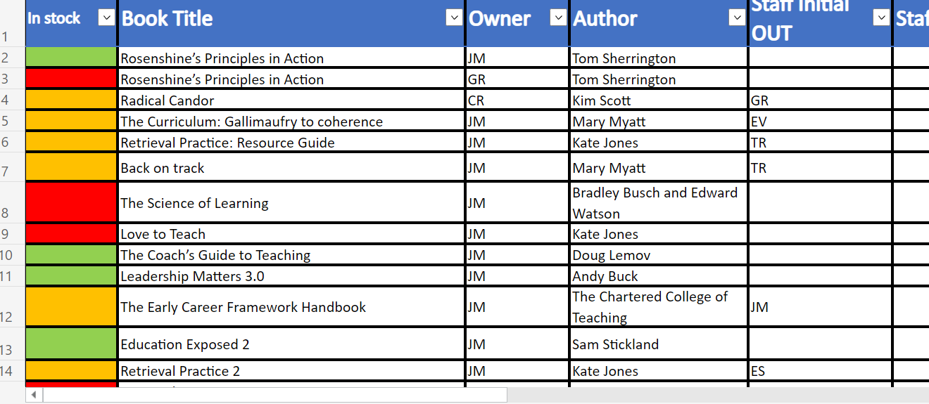 | £565
Whole staff CPD on development of of Tenet’s of Excellence and ATT Blueprint for Teaching and Learning.£ | PD focus on Rosenshine’s principles, cognitive science, cognitive load and memory and questioning.  Whole staff training on this on Sept inset.  Walkthrus being used.  Data shows an increase in staff effectiveness in 3 of the 5 key areas. The other 2 will be focus of CPD this year. | % of staff job role £8976
Time and resources to develop, undertake and reflect on Inquiry Questions | Whole staff training has taken place regularly for inquiry questions and directed time allocated to assist completion and research for this. TDA was a pilot school for IQs and outcomes were strong on this. Has now been adopted trust wide.
All Y11 students to be provided with high quality revision resources for all their exam subjects | Yr 11 received all revision resources. | £2348

Targeted academic support (for example, tutoring, one-to-one support structured interventions)
Activity | Impact of this approach | Actual Spend
Small group literacy intervention | Small group English intervention taking place to support our weakest readers. Our weakest readers have been targeted in small groups to focus specifically on raising reading and comprehension. Data shows accelerated progress from primary school. | £5,000
Bedrock Vocabulary | Bedrock did not happen. Taken on for 22/23 | n/a
Intervention sessions with school-funded trained intervention assistants and high performing subject specialists for targeted students | Intervention sessions took place for Year 11 three times a week, targeted students by experienced teaching staff from Jan 2022. | £3778  £5,656
Raising aspirations through educational visits, leadership roles and Cultural Capital experiences | Extend and Enrich opportunities. All pupils in years 7 to 10 do a year long activity/project and a half termly carousel. Ofsted October 2022 “Pupils enjoy taking part in extended curriculum sessions at the end of the day. In these sessions, they can do activities which interest them and develop them beyond academic study. Examples include singing in a choir, gardening and learning Japanese. (…) The Extend, Enrich and Prepare programme supports pupils’ wider development. All pupils select one activity which they complete for the year and another which changes every six to eight weeks”  Careers interviews, Ofsted 2022: “Pupils can have up to four one-to-one interviews with a careers adviser before they leave the school.” | £22,865

Wider strategies (for example, related to attendance, behaviour, wellbeing)
Activity | Impact of this approach | Actual Spend
Pastoral leaders trained monitor students attendance and follow up quickly on truancies. First day response provision | Updates and adaptations to the monitoring process of truancy and handling truancy related issues began mid-way through the academic year. PLs meet weekly to discuss highlighted issues.  These adaptations have had a positive impact (Summer term 2022, 66% of truancy points were PP, Autumn term 2022 this has balanced at 50% PP.)  When comparing HT6 21-22 and HT1 22-23, PP Truancy incidents had reduced by 38%. | £37,500
Increased positive contact through phone calls and emails. Encouraged attendance to parent’s events with students/parents | Positive interaction with parents is now monitored and actively promoted (38% of positive phone calls were to PP parents, roughly in line with our 40% of PP pupils).  Parents eve attendance for PP students remains behind this, currently standing at only 16%, compared to 40% of PP pupils. | N/A
Free Breakfast club place for disadvantaged students to support attendance and punctuality | Free breakfast club in place for all pupils and staff every morning. This is well attended and allows every pupil the opportunity to have breakfast. | £7465
Adoption of a cognitive behavioural therapy (CBT) intervention for specific pupils who require support with regulating their behaviour and emotions. This includes training for school staff, collaboration with our local behaviour hub and teacher release time. | Counselling service adopted CBT as a new approach for students struggling with mental health issues.  Draw and talk in place. | £13,425
Embedding principles of good practice set out in DfE’s Improving School Attendance advice. Staff will get training and release time to develop and implement new procedures. Attendance/support officers will be appointed to improve attendance. | Pastoral Leader for each year group monitor attendance. Data and interventions listed and impact measured. Attendance has remained above national all year. | As above.
Provide a high quality counselling service within the Academy setting to enable students to access counselling with minimal disruption to their attendance and education. | Pupils can be referred for counselling, draw and talk, low self esteem girls group. Reduction in PA as a result of attendance at counselling services. | £32,008
Provide bespoke interventions for individual students, including enhanced opportunities for support with a trusted adult, through the specialist support faculty. | SSF has changed, adapted and improved its support services. ‘SSF has moved and there was a noticeable reduction in students. Students were doing more curriculum work, taught at times by teachers’. | £74.007
Provide Men at Work training/intervention to support boys mental health and social interactions. | Not taken place yet. Will be moved to next year as part of wave two behaviour and culture and climate strategy. | N/A
Provide Human Utopia intervention to support wellbeing and aspiration | Not taken place yet. Will be moved to next year as part of wave two behaviour and culture and climate strategy. | N/A
Staff training for Mental Health First Aid. Staff training for trauma and attachment to support staff expert knowledge of individual students. Staff training for EMR method. | Mental Health First Aiders are now in place.  EMR – due to staffing constraints, unable to complete – will move forward to next year. | £1000
Contingency fund for acute issues and provision of resources that children might individually need. For example, uniform, additional free school meals, school trips and other activities relating to the learning journey | Have funded trips, uniform and PE Kit for students. | £8,000
Train Pastoral leaders to work with vulnerable and disadvantaged students. | External training has been provided here. Staff will have a PP focused caseload for support. | £12,000 PL time and  £2,152 external training
Develop and implement clear strategy and process for behaviour interventions | Clear behaviour pathway and intervention strategies in place. Pastoral Leaders (and the reintroduction of) Head of Years. PP focus with these staff ensuring that our PP students have a more closely monitored focus pastorally. | £26,684
Regularly monitor PP students and the amount of rewards etc that they are getting. Reward first strategies. | 37% of positive points were for PP students, roughly in line with 40% target. Still need to more greatly monitor rewards that our PP students are getting. | £4,000 time equivalent working closely with PP students and families.

