Whistleblowing

Policy & Procedure

**Published**

September 2020

**Responsible Colleagues**

CEO



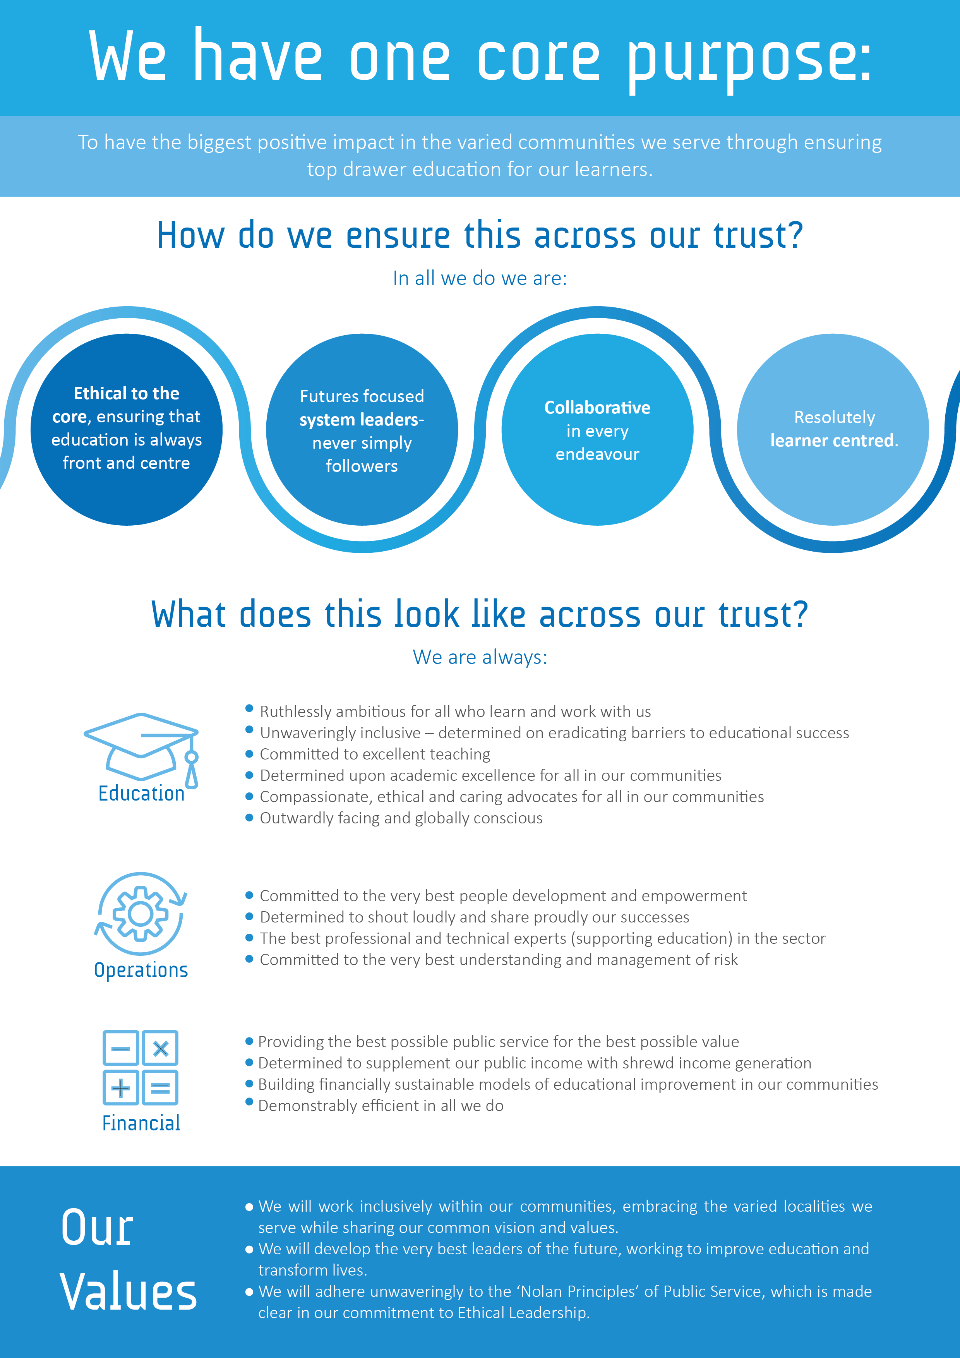

Contents

|  |  |  |
| --- | --- | --- |
|  | Statement of Intent | 4 |
| 1 | Scope of this Policy | 4 |
| 2 | What is a Whistleblowing Concern? | 5 |
| 3 | Responsibility for the Success of this Policy | 6 |
| 4 | Confidentiality and Anonymous Disclosures | 7 |
| 5 | False Allegations | 7 |
| 6 | Protection and Support for Whistleblowers | 7 |
| 7 | Whistleblowing and Safeguarding | 8 |
| 8 | How the Matter can be Taken Further | 8 |
|  | Appendix 1- Raising a Whistleblowing Concern | 10 |
|  | Appendix 2- External Support | 11 |
|  | Appendix 3- Taking Matters Further | 12 |

Statement of Intent

# We are committed to the highest possible standards of honesty and integrity, and we expect all staff to reflect these standards

# Our staff code of conduct sets out the expectations we have of all our colleagues:

We know that our professional behaviour inspires and impacts our learners. We are therefore committed to demonstrating the very best standards of behaviour. Our code of conduct and our “Academy Way” appendices aim to engender and foster exemplary behaviours which enable our people to be the best role models for our learners:

*“Being a role model is the most powerful form of educating. Youngsters need good models more than they need critics” (John Wooden)*

This code also provides a clear framework for leadership behaviours so that our aspirant leaders are always learning from the very best:

*“Example is not the main thing in influencing others. It is the only thing” (Albert Schweitzer)*

It is important, therefore, that we challenge all conduct which falls short of these high standards, and every one of our people should feel able to do this without fear. A culture of openness and accountability is essential for us to be confident of doing a good job.

# This policy provides a means for concerns to be raised under *the Public Interest Disclosure Act* (1998), which provides individuals with a certain level of legal protection if they wish to raise legitimate concerns.

It reaffirms the fact that we take all allegations of malpractice seriously and that all our staff can raise concerns outside of their line management structure if appropriate or necessary. We will always respect the confidentiality of anyone raising a concern and have relationships in place which enable anyone to also access confidential advice from an independent body if they need it.

1 | Scope of this Policy

* 1. This policy applies to all individuals working at all levels of the organisation: Members, Trustees, Local Governing Board members, all employees (including fixed term), consultants, contractors, trainees, volunteers, casual and agency staff. For the purposes of this policy, these will be collectively referred to as *staff*.
  2. Others wishing to raise concerns about an aspect of our work should use our *Complaints Policy and Procedure.*
  3. This policy should not be used for complaints relating to your own personal circumstances, such as the way you have been treated at work. In those cases, you should refer to the *Grievance Procedure* or *Dignity at Work Policy* as appropriate.
  4. Should you raise a concern whilst subject to any formal procedures, this will not halt those processes. However, we will take your concern seriously and deal with it in line with this policy.
  5. Whistleblowing concerns usually relate to the conduct of our staff, but they may sometimes relate to the actions of a third party, such as a customer, supplier, service provider or contractor. The law allows you to raise a concern in the public interest in a third party, where you reasonably believe it relates mainly to their actions or something that is legally their responsibility. However, we encourage you to report such concerns internally first.
  6. We recognise that the scope of this policy may overlap with other policies. Any concerns raised under this policy may be dealt with under the policy that seems most appropriate for the circumstances, ensuring that the welfare and interests of our learners are placed at the forefront of our response.
  7. Should we decide to deal with your concern under a different policy, we will confirm this to you in writing, however the same protections as outlined in this policy will continue to apply, provided the concern is raised in the public interest.

2 | What is a Whistleblowing Concern?

* 1. Whistleblowing is the disclosure of information which relates to **suspected wrongdoing or dangers at work**. Concerns raised under this policy should be about something that you reasonably believe is *in the public interest*. The disclosure may show one or more of the following:
* **Criminal Activity -** that a criminal offence has been committed, is being committed or is likely to be committed
* **Failure to Comply -** that a person has failed, is failing or is likely to fail to comply with any legal or professional obligation or regulatory requirements to which they are subject
* **Miscarriages of Justice -** that a miscarriage of justice has occurred, is occurring or is likely to occur
* **Danger to Health and Safety -** that the health or safety of any individual has been, is being or is likely to be endangered
* **Damage to the Environment -** that the environment has been, is being or is likely to be damaged
* **Deliberate Concealment** - that information tending to show any matter failing within any one of the preceding paragraphs has been, is being or is likely to be deliberately concealed.
  1. Disclosures of information may also include allegations of:
* Bribery, financial fraud, or mismanagement
* Negligence
* Discrimination
* Conduct likely to damage our reputation
* Unauthorised disclosure of confidential information
* Breach of internal policies and procedures
* Modern slavery or human trafficking.

These lists are not intended to be exhaustive.

* 1. This policy is intended to encourage staff to raise serious concerns internally, without fear of reprisals.
  2. Covering up someone else’s wrongdoing is a disciplinary offence. You should **never** agree to remain silent about a wrongdoing, even if you are told to do so by a person in authority, such as your line manager. You should report the matter to a more senior member of staff.

1. | Responsibility for Success of this Policy
   1. Our *Board of Trustees* has overall responsibility for this policy and for reviewing the effectiveness of actions taken in response to concerns raised under this policy.
   2. The principal has day-to-day operational responsibility for this policy within our academies and must ensure that all managers and other staff who may deal with concerns or investigations under this policy receive regular and appropriate training.
   3. For central staff, the person responsible for the day-to-day management of this policy is the *Head of Corporate Affairs*, who is also able to offer advice on specific cases.
   4. The *Board of Trustees* will review this policy as required from a legal and operational perspective and no later than three years following its implementation date. **All staff** are responsible for the success of this policy and should ensure that they use it to disclose any suspected danger or wrongdoing. Staff are invited to comment on this policy and suggest ways in which it might be improved.
2. | Confidentiality and Anonymous Disclosures
   1. We are committed to treating all concerns in confidence and will do our best to protect your identity. It may become necessary to disclose your identity as part of an investigation, for instance if police involvement is required, however this will not be done until the reasons for this have been fully discussed with you.
   2. We do not encourage anonymous disclosures. Proper investigation may be more difficult or impossible if we cannot obtain further information from you and we would not be able to provide you with feedback on our investigation or outcomes. It is also more difficult to establish whether any allegations are credible and have been made in the public interest.
   3. We will use our discretion when deciding whether to investigate an anonymous disclosure. Factors that may be taken into consideration when making this decision include the seriousness of the issue raised and the likelihood of confirming the allegation through other sources.
3. | False Allegations
   1. If you make what you believe to be a genuine allegation in the public interest under this policy and, following investigation, your allegation is not confirmed then no action will be taken against you. We would rather allegations were raised, provided this is done in good faith.
   2. If, following an investigation, it is concluded that your allegation was of a vexatious or malicious nature then you may be subject to disciplinary action.

6 | Protection and Support for Whistleblowers

* 1. We recognise the decision to report a concern can be difficult one to make and will take action to protect you if you raise a concern.
  2. You will not suffer any detrimental treatment as a result of raising a concern in the public interest. Detrimental treatment includes dismissal, disciplinary action, threats or other unfavourable treatment from the employer or co-workers connected with raising a concern. If you believe that you have suffered any such treatment, you should inform the principal or CEO immediately.
  3. If the matter is not remedied, you should raise it formally using our *Grievance Procedure*. Staff must not threaten or retaliate against whistle-blowers in any way. Anyone involved in such activity will be subject to disciplinary action.
  4. If you feel you need further support throughout this process or prior to raising a concern, you are encouraged to contact your union. We have an *Employee Assistance Programme* (EAP) available to all employees free of charge. If employees feel troubled by this process, they can contact the EAP for free confidential advice and support by calling **0800 107 6585**. There is also a website available: [www.employeecare.com](http://www.employeecare.com). The access code and password for this service is **72247.**

7 | Whistleblowing and Safeguarding

* 1. We recognise that children cannot be expected to raise concerns in an environment where staff fail to do so.
  2. All staff should be aware of their duty to raise concerns about the attitude or actions of colleagues. If you are concerned that a member of staff or adult in a position of trust poses a danger to a child or young person or that they might be abusing a child or young person you should report your concerns to the principal in the first instance. Where those concerns relate to the principal the concerns should be reported to the Director of Secondary Education or the Director of Primary Education and will be addressed using the procedure for dealing with allegations of abuse against staff.

8 | How the Matter can be Taken Further

* 1. The aim of this policy is to provide an internal mechanism for reporting, investigating, and remedying any wrongdoing in the workplace. In most cases you should not find it necessary to alert anyone externally. The law recognises that in some circumstances it may be appropriate for you to report your concerns to an external body such as a regulator. It will rarely, if ever, be appropriate to alert the media.
  2. We strongly encourage you to seek advice before reporting a concern to anyone external. The independent whistleblowing charity, Public Concern at Work, operates a confidential helpline. They also have a list of prescribed regulators for reporting certain types of concern. Further information on this can be found in Appendix 2.
  3. Where the concern relates to Child Protection, the **NSPCC Whistleblowing Advice Line** offers free advice and support to professionals with concerns about how Child Protection issues are being handled in their own or another organisation. Further information on this can be found in Appendix 2.
  4. If you are not satisfied with the actions taken by us regarding a concern you have raised and you feel it is right to take the matter further, possible contact points are provided in Appendix 3.

Appendix 1- Raising a Whistleblowing Concern

## In line with our commitment to honesty and integrity, we actively encourage staff with genuine concerns to raise these. **The process is outlined below.**

## We hope that in many cases you will be able to raise any concerns with **your line manager**. You may tell them in person or put the matter in writing if you prefer. They may be able to agree a way of resolving your concern quickly and effectively. In some cases, they may refer the matter to the principal or a more senior member of the executive.

## However, where the matter is more serious, you feel that your line manager has not addressed your concern, or you prefer not to raise it with them for any reason, you should contact one of the following:

###### The Principal

###### The Vice Principal

###### Director of Secondary Education or the Director of Primary Education

###### The Chief Executive Officer

* The Chair of the Trust’s Audit Committee, who is our named Trustee for this purpose – currently Mark Gill, who can be contacted at [mark.gill@attrust.org.uk](mailto:mark.gill@attrust.org.uk).

## The person you contact will be responsible for arranging a meeting with you as soon as possible to discuss your concern. You may bring a colleague or trade union representative to any meetings held under this policy. Your companion must respect the confidentiality of your disclosure and any subsequent investigation. A written summary of your concern will be made at the meeting, and you will be provided with a copy as soon as is practicable after the meeting.

# Investigation and Outcome

## Once you have raised a concern, the person you have contacted will be responsible for ensuring that an initial assessment is carried out to determine the scope of any investigation. The person you contact may delegate the initial assessment to another appropriate person. They will inform you of the outcome of the assessment.

## You may be required to attend additional meetings to provide further information. In some cases, an internal or external investigator or investigators may be appointed. The investigator(s) may make recommendations for change to enable us to minimise the risk of future wrongdoings.

## The person you raised your concern with, or the investigator(s), where appointed, will aim to keep you informed of the progress of the investigation and its likely timescale. However, sometimes the need for confidentiality may prevent them giving you specific details of the investigation or any disciplinary action taken as a result. You should treat any information about the investigation as confidential.

Appendix 2- External Support

The independent whistle blowing charity, Public Concern at Work, operates a confidential helpline **on 020 7404 6609**. They also provide a list of prescribed regulators for reporting certain types of concern which can be found below:

* **Advice, Conciliation and Arbitration Service (ACAS)**

For information and help on employment issues and dispute resolution.

0300 123 1100  
[www.acas.org.uk](http://www.acas.org.uk)

* **Community Legal Service**

For free information, help and advice direct to the public on a range of common legal issues.

0845 345 4345  
[www.legalservices.gov.uk](http://www.legalservices.gov.uk)

* **Equality Advisory and Support Service (EASS)**

For advice on discrimination issues.

0808 800 0082  
[www.equalityadvisoryservice.com](http://www.equalityadvisoryservice.com)

* **Liberty**

For advice on human rights.

020 7329 5100/020 3145 0460  
[www.liberty-human-rights.org.uk](http://www.liberty-human-rights.org.uk)

* **Local Citizens Advice Bureau**

For general advice and information on a range of legal fields.

03444 111444  
[www.citizensadvice.org.uk](http://www.citizensadvice.org.uk)

* **Local Law Centre**

For free legal advice and in some cases representation.

[info@lawcentres.org.uk](mailto:info@lawcentres.org.uk)  
[www.lawcentres.org.uk](http://www.lawcentres.org.uk)

* **Pay and Work Rights Helpline**

For help and advice on government enforced rights.

0800 917 2368

* **Royal Mencap Society**

For whistleblowing advice for workers in health and adult social care.

08000 724 725

* **NSPCC Whistleblowing helpline**

For advice and support to professionals with concerns about how child protection issues are being handled in their own or another organisation.

0800 028 0285  
Email [help@nspcc.org.uk](mailto:help@nspcc.org.uk)

Appendix 3- Taking Matters Further

If you are dissatisfied with the action we have taken regarding a concern you have raised, and you feel it is right to refer the matter to an external body, then the following possible contact points could be used.

* The Department for Education.
* Member of Parliament.
* National Audit Office.
* Health and Safety Executive.
* Police.

If you do not feel able to raise your concern using the external bodies outlined above, you should consult *the Public Interest Disclosure Act* for information about other routes by which a disclosure may be made.