## **Transition into L3 BTEC National Extended certificate into Applied Science**



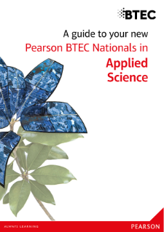

**Contents**

**Course Information**

**Course Expectations**

**key terms**

**Recommended reading list**

**Movie/ video clip recommendations**

**Subject Content**

**Course Information**

**Course being studied**

**BTEC National Extended Certificate in Applied Science**

**Units studied**

**Unit 1: Principles and Applications of Science 1 (External assessment)**

**Unit 2: Practical Scientific Procedures and Techniques (Internal assessment)**

**Unit 3: Science Investigative Skills (external assessment)**

**Unit 8 Physiology of Human Body Systems (internal assessment))**

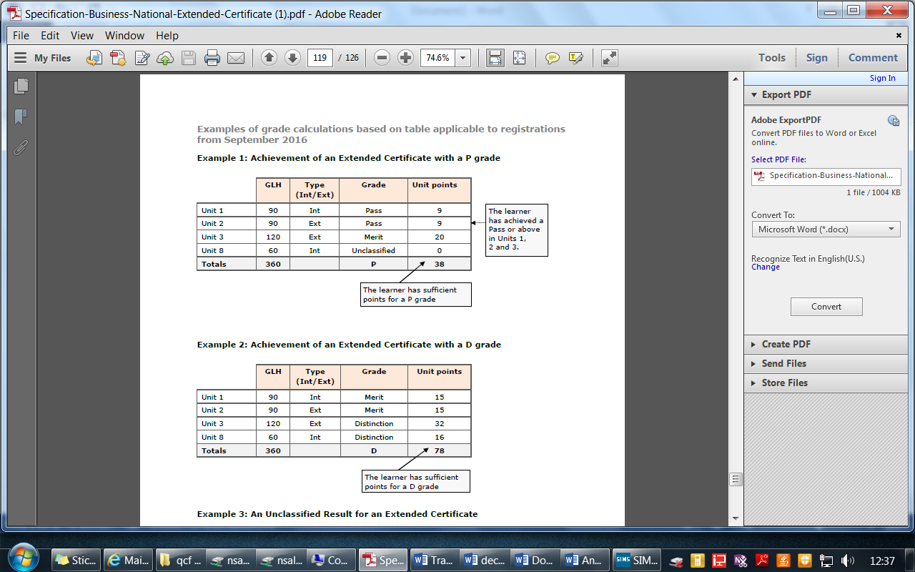

**Grading criteria**

**The criteria for each unit varies between a pass to a distinction, a combination of grades can be achieved, and an example for a pass and Distinction is below.**

**You *Must* achieve at least a Pass in unit 1 in order to complete the course**

**Course Expectations**

* **100% attendance to lessons**
* **Excellent behaviour towards the learning environment**
* **Positive contributions to class discussions**
* **Participate in presentations, work as a team when required and take part in all practical tasks.**
* **To complete all homework and assignments by deadline dates.**

A willingness to read around the subject.

Attendance at support sessions when directed by teachers

**Assessment Expectations**

**All learner work must be submitted on the given deadline day. If not the grade will be capped at pass level regardless of criteria.**

**All leaners work needs to have the name and assignment title in the header and page numbers in the footer.**

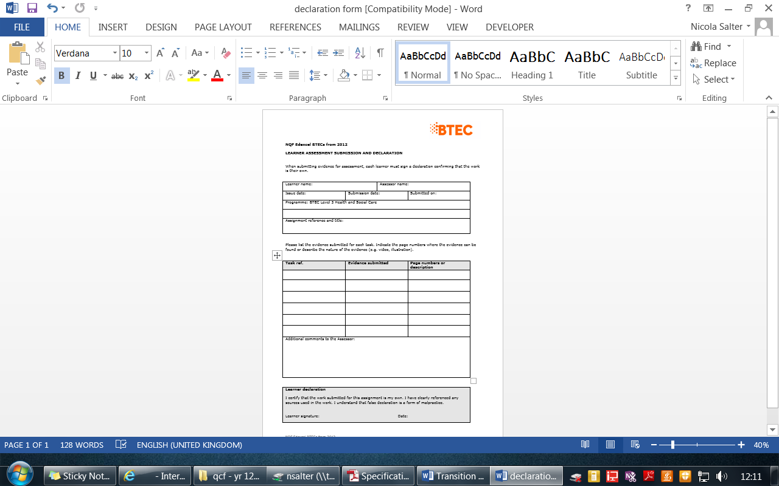**All learners need to have a submitted their work with a signed declaration form, this form states that is your own work!**

**Key terms used to define the requirements in the units**

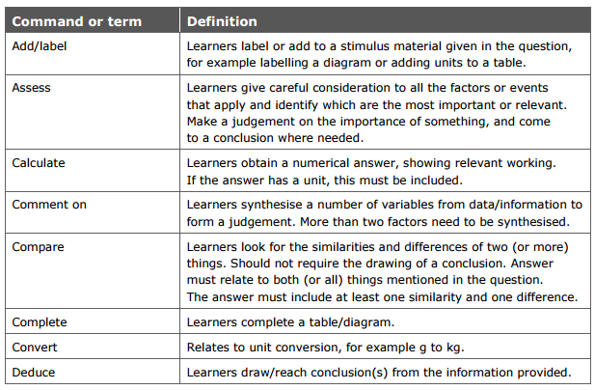

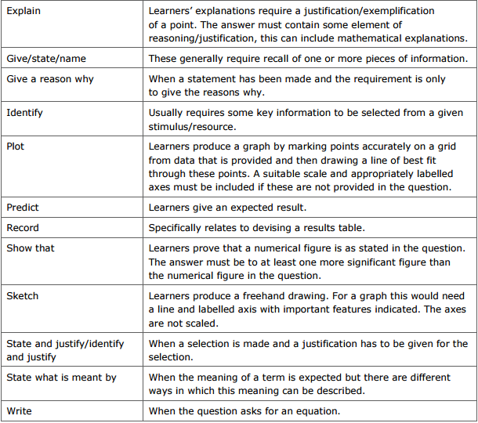

**Command or term Definition**

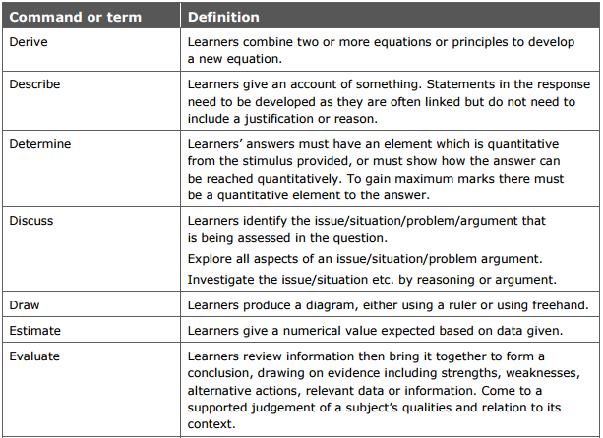

**Recommended reading list**

Physics for you by Keith Johnson

Chemistry for you by Lawrie Ryan

Biology for you by Gareth Williams

BTEC Nationals Applied Science: Student Book Level 3 (BTEC Nationals Applied Science 2016)  by Joanne Hartley

**Websites**

<http://www.biologymad.com/>

[www.sparknotes.com](http://www.sparknotes.com)

[www.s-cool.co.uk](http://www.s-cool.co.uk)

**Movie/ Video Clip recommendations**

Atomic and electronic structure

<https://www.youtube.com/watch?v=H0rFDakTI-0>

ionic and covalent bonds

<https://www.youtube.com/watch?v=wQ3NJUKKcTU>

History of the microscope

<https://www.youtube.com/watch?v=Ue-86MDmjns>

cell structure

<https://www.youtube.com/watch?v=URUJD5NEXC8>

spcialised cells

<https://www.youtube.com/watch?v=RqbkTT63yeE>

Structure and function of the blood

<https://www.youtube.com/watch?v=noMsCGRkwSE>

Longitudinal and transverse waves

<https://www.youtube.com/watch?v=ZADaRGEUCDw>

electromagnetic spectrum

<https://www.youtube.com/watch?v=HPcAWNlVl-8>

**Subject content**

**History of the microscope**

Draw and label a diagram of a microscope

Describe what microscopes are used for

**Research the history of the microscope**

* Produce a timeline showing the main developments in the microscope
* Identify the scientists involved in the development of the microscope
* Describe how the microscope has changed over the years

Using the website <http://www.cellsalive.com/> Produce a diagram of an animal and a plant cell including all of the subcellular structures.

Draw a diagram of an atom

Describe the structure of an atom

Complete the tale below

|  |  |  |
| --- | --- | --- |
| Particle | Relative mass | Charge |
| Proton |  |  |
| Neutron |  |  |
| Electron |  |  |

**Research the meaning of stoichiometry and produce an A4 sheet that summarises what you have already used in this branch of chemistry**

Draw a diagram and annotate to describe the separation technique: paper chromatography

Research a 2nd method of chromatography called thin layer chromatography (TLC) and explain how it is different to paper chromatography

Explain what Rf values are and how they can be calculated

Produce a poster on the periodic table, include descriptions of

* The groups
* The development of the periodic table
* Atomic mass
* Transition elements
* rows

|  |  |
| --- | --- |
| **longitudinal** | **Transverse** |
|  |  |

Research and compare longitudinal and transverse waves. Include:

* A labelled diagram
* A description
* examples

**Draw a diagram of a wave**

On the diagram label the amplitude and wavelength

In musical instruments, how does changing the frequency effect the sound of the wave?

How does changing the amplitude effect the sound of the wave?

Research the electromagnetic spectrum and produce a leaflet on its properties.

Include,

* All of the waves
* The frequency and wavelength of each wave
* Uses of each type of wave
* What all the waves have in common.

What is an endoscope?

Explain the use of an endoscope in medicine

Research what Bluetooth is, and how is it used in communication.

What is broadband? How does it work?