## **Transition into L3 BTEC National Health and Social Care**

[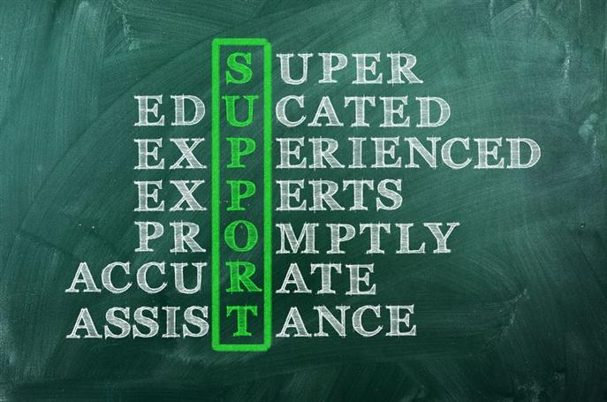](http://www.google.co.uk/url?sa=i&rct=j&q=&esrc=s&source=images&cd=&cad=rja&uact=8&ved=0ahUKEwiQ3Oa7pMjNAhWGLMAKHZYjAPAQjRwIBw&url=http://www.fhtgrouptours.com/_s10/-health-and-social-care.aspx&psig=AFQjCNEAGO4i_FvLP1M-CC1Xrt7Sqa7a3w&ust=1467119548005844)

Getting ready for BTEC National Health and Social Care

**A guide to the course to help you get ready for Health and Social Care**

**Contents**

**Course Information**

**Course Expectations**

**Pre knowledge key terms**

**Recommendation reading list**

**Movie/ video clip recommendations**

**Website to research**

**Transition activity**

**Course Information**

**Course being studied**

**BTEC National Foundation Diploma in Health and Social Care**

**Units studied**

**Unit 1: Human Lifespan Development\***

**Unit 2: Working in Health and Social Care\***

**Unit 5: Meeting individual Care and Support needs**

**Unit 7: Principles of safe practice in Health and Social Care**

**These unit are mandatory and are required to complete the course. Unit 1 and unit 2 are externally assessed.**

**Additional unit required to complete the course**

**Unit 6: Work Experience in Health and Social Care**

**Unit 12: Supporting Individuals with Additional Needs**

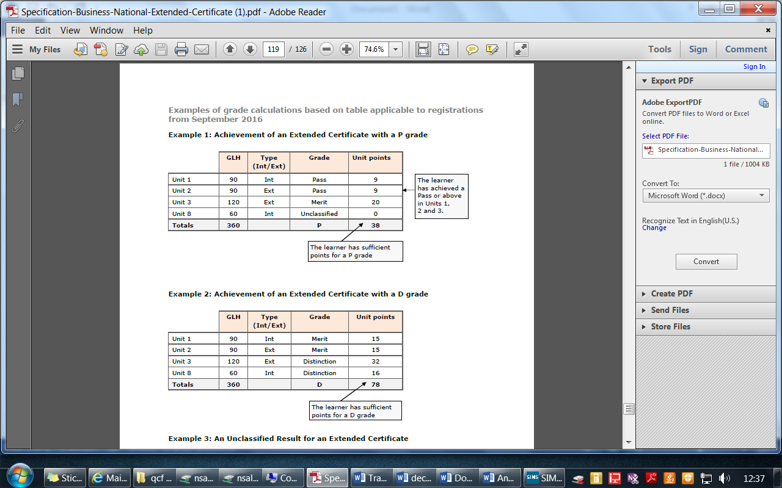**This requires the learner to undertake a period of work relating to the course**

**Grading criteria**

**The criteria for each unit varies between a pass to a distinction, a combination of grades can be achieved, and an example for a pass and Distinction is below.**

**Important information regarding mandatory units!**

**You must pass all the mandatory units at a pass or above to complete the course**

**Course Expectations**

* **100% attendance to lessons**
* **Excellent behaviour towards the learning environment**
* **Positive contributions to class discussions**
* **Participate in presentations and work as a team when required**
* **Submit all coursework on time!**

**Assessment Expectations**

**All learner work must be submitted on the given deadline day. If not the grade will be capped at pass level regardless of criteria.**

**All leaners work needs to have the name and assignment title in the header and page numbers in the footer.**

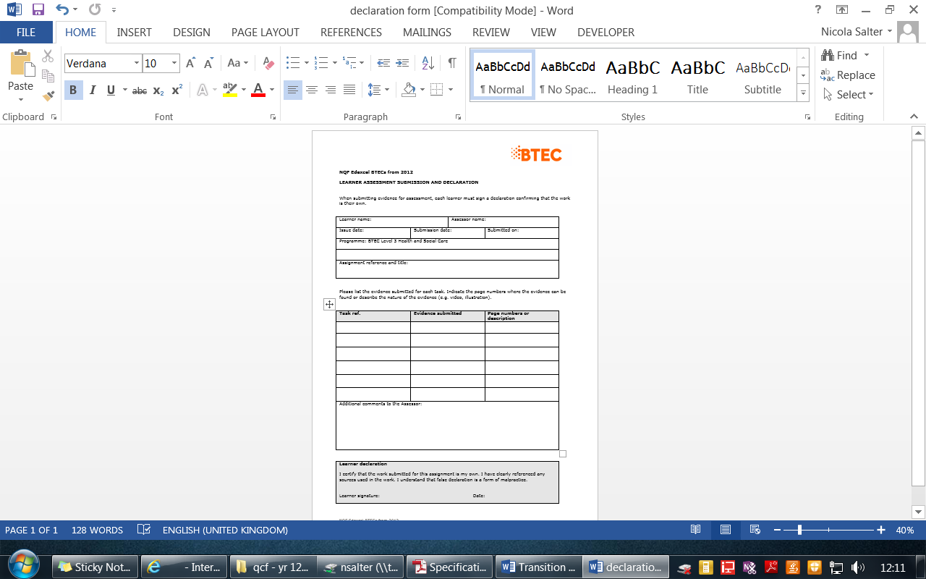**All learners need to have a submitted their work with a signed declaration form, this form states that is your own work!**

**Pre knowledge = Key terms you should understand**

**How to learn these key words**

Flash cards are a great way to learn the key words, write the command word on one side and the definition on the other. Practice by asking someone to test you.

Simple look, cover and test- practice the command word and definition and then write the definition on a blank piece of paper.

**Command or term Definition**

|  |  |
| --- | --- |
| *Command/ term* | *Definition* |
| **Primary research** | Research compiled directly from the original source, which may not have been compiled before. Learners are expected to understand the advantages and disadvantages of different primary research methods. |
| **Qualitative research** | Descriptive data, such as data drawn from open-ended questions in questionnaires, interviews or focus groups. |
| **Quantitative research** | Data in numerical form which can be categorised and used to construct graphs or tables of raw data. |
| **Secondary sources/research** | Published research reports and data, likely to be based on analysis of primary research. |

**Pre knowledge = Key terms you should understand**

|  |  |
| --- | --- |
| Command or term | Definition |
| **Assess** | Learners present a careful consideration of varied factors or events that apply to a specific situation or to identify those which are the most important or relevant and arrive at a conclusion. |
| **Discuss** | Learners consider different aspects of:   * A theme or topic how they interrelate; * The extent to which they are important.   A conclusion is not required. |
| **Evaluate** | Learners’ work draws on varied information, themes or concepts to consider aspects  such as:  • strengths or weaknesses  • advantages or disadvantages;  • alternative actions  • Relevance or significance.  Learners’ inquiries should lead to a supported judgement showing relationship to its context.  This will often be in a conclusion. Evidence will be written. |
| **Explain** | Learners’ work shows clear details and gives reasons and/or evidence to support an opinion, view or argument. It could show how conclusions are drawn (arrived at). Learners are able to show that they comprehend the origins, functions and objectives of a subject, and its suitability for purpose. |
| **Give** | Learners can provide:  • examples  • Justifications. |
| **Identify** | Learners indicate the main features or purpose of something by recognising it and/or being able to discern and understand facts or qualities. |
| **Illustrate** | Learners include examples, images or diagrams to show what is meant in a specific context. |
| **Outline** | Learners’ work, performance or practice gives a summary or overview or a brief description of something. |

**Recommendation reading list**

**Films:**

* **Wonder - (PG) Inspiring story of a boy with facial differences who enters the fifth grade, attending a mainstream elementary school for the first time. Coping with being different. Coping with life/life events**
* **Hidden figures – (PG) Anti discrimination. Care values**
* **Still Alice – (12A) Story of a woman living with Alzheimer's disease. Illness/Disorders**
* **My sister’s keeper – (12A) "The only way to save your daughter is to sacrifice her sister". Anna has never been given a choice: she was born to be her sister Kate's bone marrow donor and she has always given Kate everything she needs. Relationships/family**
* **Three identical strangers – (12A) Identical triplets become separated at birth and adopted by three different families. Years later, their amazing reunion becomes a global sensation. Relationships/family**
* **Bohemian Rhapsody – (12A) Freddy Mercury defies stereotypes and convention to become one of history's most beloved entertainers. Lifestyle factors/social & cultural stereotypes**
* **Me before You – (12A) A young and quirky woman becomes a caregiver for a wealthy young banker left paralysed from an accident two years earlier. Life events/formal & informal care/disability**
* **The Children Act – (12A) Adam Henry has leukaemia. His doctors want to perform a blood transfusion but his parents are Jehovah’s Witnesses, and believe that having a blood transfusion is against biblical principles. Illness/ethics/relationships**
* **To the bone – (15 Netflix) Eating disorders/anorexia Diet and appearance**
* **Sorry we missed you (15) Ricky and his family have been fighting an uphill struggle against debt since the financial crash. Social & cultural factors/income & wealth/life circumstances**
* **The Upside - (12A) The relationship between a wealthy man with quadriplegia and a recent unemployed ex-convict. Disability/relationships**

**TV programmes:**

* **Babies : their wonderful world – BBC. Explores how the first 2 years of life shapes the adults we become. Infancy development/lifestages**
* **The secret life of 4 and 5 year olds – Channel 4. Great for looking at childhood development/lifestages (especially socialisation skills)**
* **Old people’s home for 4 year olds – Channel 4. How the company of 4 year olds helped to improve the mood, mobility and memory of the elderly. Lifestages.**
* **Born to be different – Channel 4. The pressures and joys of bringing up a disabled child https://www.channel4.com/programmes/born-to-be-different/ Disability/infancy and childhood/life events. · Speech journey – You Tube. https://www.youtube.com/watch?v=jt7y1IM2jOM How children learn to talk from birth to 5 years old. Intellectual development**
* **Mum, Dad, Alzheimer’s and Me – You Tube. Real life story investigating the care of Alzheimers sufferers in the UK. https://www.youtube.com/watch?v=LprTLaO1AF0**

**Old age/disorders**

* **Louis Theroux, Extreme Love: Dementia – BBC 2 Sufferers and carers explore the struggle of living with dementia. Disorders/formal and informal carers**

**Books :**

* **David Pelzer, A Child Called It**
* **Davide Pelzer, A Man Named Dave**
* **Adam Kay, This is Going to Hurt**
* **Brian Conaghan, The Weight of a Thousand Feathers**
* **Alex Michaelides, The Silent Patient**
* **Richard Shepherd, Unnatural Causes**
* **Malala Yousafzai, I Am Malala: The Girl Who Stood Up for Education and was Shot by the Taliban**
* **R J Palacio, Wonder**
* **Angie Thomas, The Hate U Give**
* **Michael Newton, Savage Girls and Wild Boys: A History of Feral Children**

**Movie/ Video Clip recommendations**

<http://www.fhtgrouptours.com/uploaded/images/large/309-health-and-social-care.jpg>

Write your opinion on the video

<https://www.youtube.com/watch?v=HBIYwiktPsQ&list=PLaHOvxadLDLBfXiKcXbrLKd_DCdOdaMZD>

**Inside the living body** write your opinion to the video, did it help you understand the human lifespan?

<https://www.youtube.com/watch?v=d9eno8wUrUs>

**Child of our times** Write your opinion on the video

**Website to research**

Unit 1: Human Lifespan Development

[www.communitycare.co.uk](http://www.communitycare.co.uk) Community Care magazine

[www.dh.gov.uk](http://www.dh.gov.uk) Department of Health

[www.nursingtimes.net](http://www.nursingtimes.net) Nursing Times

**Unit 1: Human Lifespan Development**

The following task are directly linked to your **external assessment** unit which will be taken in **May/ June 2018**. It is important you focus on these tasks as they will need to be understood and recalled for your exam. All the tasks have been developed through the content of the unit and will be within the scope of the examination questions.

**Unit in brief**

You will cover physical, intellectual, emotional and social development across the human lifespan, and the factors affecting development and the effects of ageing.

**Introduction to the unit**

Health and social care practitioners need to develop a knowledge base for working with people in every stage of their lives, and they need to know how their own experiences relate to health and wellbeing. Although it is generally accepted that there may be deterioration in health with age following adulthood, medical intervention means people are living longer and have better life prospects.

This unit will develop your knowledge and understanding of patterns of human growth and development. You will explore the key aspects of growth and development, and the experience of health and wellbeing. You will learn about factors that can influence human growth, development and human health. Some of these are inherited and some are acquired through environmental, social or financial factors during our lifespan. You will learn about a number of theories and models to explain and interpret behaviour through the human lifespan. In this unit, you will explore the impact of both predictable and unpredictable life events, and recognise how they impact on individuals. You will study the interaction between the physical and psychological factors of the ageing process, and how this affects confidence and self-esteem, which in turn may determine how individuals will view their remaining years.

This unit is externally assessed. It covers aspects of human growth and development through the different life stages. This content will serve as an introduction to health and social care needs and so will sit at the heart of the qualification.

**Summary of assessment**

The unit will be assessed through one examination of 90 marks lasting 1 hour and 30 minutes.

**Glossary of words that will be within the external assessment**

|  |  |
| --- | --- |
| Command or term | Definition |
| Article | The pre-released account of a piece of recent research relating to an aspect of health or social care. Could be based on a longer research report. |
| By how many | Learners calculate an item in relation to another. For example, ‘By how many times has the probability of… |
| Compare and contrast | Learners can identify the main factors relating to two or more items/situations or aspects of a subject that is extended to explain the similarities, differences, advantages and disadvantages. For example, ‘Compare and contrast the procedures used in…’ |
| Complete | Learners provide all items. For example, ‘Complete the diagram…’ |
| Deduce | Learners reach a conclusion about something by reasoning. For example, ‘Deduce the probability of…’ |
| Define | Learners state or describe the nature, scope or meaning of a subject as objective facts. For example, ‘Define the term inherited condition’ |
| Describe | Learners give a clear, objective account in their own words showing recall, and in some cases application, of the relevant features and information about a subject. For example, ‘Describe gross and fine motor skills in relation to…’. |
| Discuss | Learners consider different aspects of a topic, how they interrelate and the extent to which they are important. For example, ‘Discuss how both the environment and genetic factors may account for…’. |
| Ethical issue | Ethically related aspects that may have affected how the research was carried out. |
| Evaluate | Learners draw on varied information, themes or concepts to consider aspects such as strengths or weaknesses, advantages or disadvantages, alternative actions, and relevance or significance. For example, ‘Evaluate possible explanations for the development of…’ |
| In which | Learners specify a particular item. For example, ‘In which trimester is the woman likely to…’. |
| Issue | May be used on its own to describe the subject of the research that the article is describing. |
| Justify | Learners give reasons or evidence to support an opinion or prove something right or reasonable. For example, ‘Justify how overcoming…’ |
| Literature review | An assessment of existing research around a particular issue or area of study. |
| Outline | Learners provide a summary or overview or a brief description of something. For example, ‘Outline ways in which this might affect their physical health.’ |
| Primary research | Research compiled directly from the original source, which may not have been compiled before. Learners are not expected to carry out primary research, but they are expected to understand the advantages and disadvantages of different primary research methods. |
| Explain | Learners show they understand the origins, functions and objectives of a subject and its suitability for purpose. They give reasons to support an opinion, view or argument, with clear details. For example, ‘Explain two possible features of the development of…’. |
| Health and social care practice | Used in relation to how health and social care professionals carry out their work or job roles. |
| Health and social care services | May be used in relation to how services are provided and/or made available to the individuals that need them. |
| Identify | Learners indicate the main features or purpose of something, and/or are able to discern and understand facts or qualities. For example, ‘Identify the services that might be available to…’ |
| Research methods | Refers to how the research described in the article was carried out, for example through quantitative methods such as analysis of figures drawn from hospitals or GP surgeries; or qualitative based on focus groups, questionnaires. |
| Secondary sources/research | Published research reports and data, likely to be based on analysis of primary research. |
| State | Learners express facts about something definitely or clearly. For example, ‘State the names of the…’. |
| To what extent | Learners show clear details and give reasons and/or evidence to support an opinion, view or argument. It could show how conclusions are drawn (arrived at). For example, ‘To what extent might recent…’ |
| What | Learners specify one or more items from a definite set. For example, ‘What is the percentage of…’ |
| Which | Learners specify one or more items from a definite set. For example, ‘Which body part…’ |
| Provide a key | Learners correspond an item to another. For example, ‘Provide a key for Graph…’. |
| Qualitative research | Descriptive data, such as data drawn from open-ended questions in questionnaires, interviews or focus groups. |

Human Lifespan

Task

Complete a timeline showing all six stages of development. They must be in the correct order with age range on.

Examine reasons why individuals may experience additional needs

Task 1

Make a list of what you think the term ‘additional needs’ means to:

A wheelchair user

…………………………………………………………………………………………………………………………………………………………………………………………………………………………………………………………………………………………………………………………………………………………………………………………………………………………………………………………………………………………………………………………………………………………………………………………………………………………………………………………………………………………………………………………………………………………………………………………………………………………………………………………………………………………………………………………………………………………………………………………………………………………………………………………………………………………………………………………………………………………………………………………………………………..

A blind person

…………………………………………………………………………………………………………………………………………………………………………………………………………………………………………………………………………………………………………………………………………………………………………………………………………………………………………………………………………………………………………………………………………………………………………………………………………………………………………………………………………………………………………………………………………………………………………………………………………………………………………………………………………………………………………………………………………………………………………………………………………………………………………………………………………………………………………………………………………………………………………………………………………………..

A person with a terminal illness

……………………………………………………………………………………………………………………………………………………………………………………………………………………………………………………………………………………………………………………………………………………………………………………………………………………………………………………………………………………………………………………………………………………………………………………………………………………………………………………………………………………………………………………………………………………………………………………………………………………………………………………………………………………………………………………………………………………………………………………………………………………………………………………………………………………………………………………………………………………………………………………………………………………

A deaf person

………………………………………………………………………………………………………………………………………………………………………………………………………………………………………………………………………………………………………………………………………………………………………………………………………………………………………………………………………………………………………………………………………………………………………………………………………………………………………………………………………………………………………………………………………………………………………………………………………………………………………………………………………………………………………………………………………………………………………………………………………………………………………………………………………………………………………………………………………………………………………………………………………………………………………………………………………………………………………………………………………………………………………

Task 2: Now choose an individual with additional needs.

Explain what their needs are in a variety of situations, including travelling, working, getting dressed.

……………………………………………………………………………………………………………………………………………………………………………………………………………………………………………………………………………………………………………………………………………………………………………………………………………………………………………………………………………………………………………………………………………………………………………………………………………………………………………………………………………………………………………………………………………………………………………………………………………………………………………………………………………………………………………………………………………………………………………………………………………………………………………………………………………………………………………………………………………………………………………………………………………………………………………………………………………………………………………………………………………………………………………………………………………………………………………………………………………………………………………………………………………………………………………………………………………………………………………………………………………………………………………………………………………………………………………………………………………………………………………………………………………………………………………………………………………………………………………………………………………………………………………………………………………………………………………………………………………………………………………………………………………………………………………………………………………………………………………………………………………………………………………………………………………………………………………………………………………………………………………………………………………………………………………………………………………………………………………………………………………………………………………………………………………..

Examine reasons why individuals may experience additional needs

Diagnosing or determining additional needs

Research the following key words:

Mild learning disabilities:

………………………………………………………………………………………………………………………………………………………………………………………………………………………………………………………………………………………………………………………………………………………………………………………………………………………………………………………………………………………………………………………………………………………………………………………………………..

Moderate learning disabilities:

…………………………………………………………………………………………………………………………………………………………………………………………………………………………………………………………………………………………………………………………………………………………………………………………………………………………………………………………………………………………………………………………………………………………………………………………………………

Severe learning disabilities:

………………………………………………………………………………………………………………………………………………………………………………………………………………………………………………………………………………………………………………………………………………………………………………………………………………………………………………………………………………………………………………………………………………………………………………………………………..

Key terms you must learn!!!

**Diagnose:**

Identify the nature of an illness or other medical condition by examination of the symptoms

**Symptoms:**

Physical or mental features of a medical condition, which can be seen or felt by the patient, for example a headache or redness of the skin. They are often subjective and may not be visible to other people.

Task

What are learning disabilities?

…………………………………………………………………………………………………………………………………………………………………………………………………………………………………………………………………………………………………………………………………………………………………………………………………………………………………………………………………………………………………………………….

How are learning disabilities diagnosed?

Task: Research the following sources a create an overview/ fact sheet for each of what they provide for individuals with learning disabilities

British institute of Learning Disabilities (BILD)

NHS Choices

Government white papers

Valuing people: A new Strategy for Learning Disability for the 21st Century (2001)

What is it?

………………………………………………………………………………………………………………………………………………………………………………………………………………………………………………………………………………………………………………………………………………………………………………………………………………………………………………………………………………………………………………………………………………………………………………………………………………………………………………………………………………………………………………………………………………………………………………………………………………………………………………………………………………

How does it help someone with learning disabilities?

………………………………………………………………………………………………………………………………………………………………………………………………………………………………………………………………………………………………………………………………………………………………………………………………………………………………………………………………………………………………………………………………………………………………………………………………………………………………………………………………………………………………………………………………………………………………………………………………………………………………………………………………………………………………………………………………………………………………………………………………………………………………………………………………………………………………………………………………………………………………………………………………………………………………………………………………………………………………………………………………………………………………………………………………………………………………………………………………………………………………………………………………………………………………………………………………………………………………………………………………………………………………………………………………………………………………

Diagnostic procedures, tools and standards used to diagnose a disability

There are four descriptions of learning disabilities. Mild, moderate, severe and profound.

|  |  |  |
| --- | --- | --- |
| Learning disabilities | Definition | Level up |
| Mild |  |  |
| Moderate |  |  |
| Severe |  |  |
| Profound |  |  |

Dyslexia

Definition of Dyslexia

……………………………………………………………………………………………………………………………………………………………………………………………………………………………………………………………………………………………………………………………………………………………………………………………………………………………………………………………………………………………………………………………………………………………………………………………………………………………………………………………………………………………………………………………………………………………………………………………………………………………………………………………………………………………………………………………………………………………………………………………………………………………………………………………………………………………………………………………………………………………………………………………………………………………………………………………………………………………………………………………………………………………………………………………………………………………………………………………………………………………………………………………………………………………………………………………………………………………………………………………………………………………

Task: Dyslexia diagnostic assessment

Create a timeline of a how someone would be diagnosed with dyslexia and what support would be provided and how it would provide better health and wellbeing.