**The Bridge to A level**

**Test yourself**



**1 Solving quadratic equations**

**Question 1**

Find the real roots of the equation x4 – 5x2 – 36 = 0 by considering it as a quadratic equation in x2

(4)

**Question 2**

(i) Write 4x2 - 24x + 27 in the form of a(x - b)2 + c

(4)

(ii) State the coordinates of the minimum point on the curve y = 4x2 - 24x + 27.

(2)

**Total / 10**

**2 Changing the Subject**

**Question 1**

Make t the subject of the formula s = at2

(3)

**Question 2**

Make x the subject of 3x – 5y = y - mx

(3)

**Question 3**

Make x the subject of the equation y = $\frac{x+3}{x-2}$

(4)

**Total / 10**

**3 Simultaneous equations**

**Question 1**

Find the coordinates of the point of intersection of the lines x + 2y = 5 and y = 5x - 1

(3)

**Question 2**

The lines y =5x – *a* and y = 2x + 18 meet at the point (7,*b*).

Find the values of *a* and *b*.

(3)

**Question 3**

A line and a curve has the following equations :

3x + 2y = 7 y = x2 – 2x + 3

Find the coordinates of the points of intersection of the line and the curve by solving these simultaneous equations algebraically

(4)

**Total / 10**

**4 Surds**

**Question 1**

(i) Simplify $\sqrt{24 }$ + $\sqrt{6}$

(2)

(ii) Express $\frac{36}{5- \sqrt{7}}$ in the form *a* + *b $\sqrt{7}$*, where *a* and *b* are integers.

(3)

**Question 2**

(i) Simplify 6 $\sqrt{2}$ x 5 $\sqrt{3}$- $\sqrt{24}$

(2)

(ii) Express ( 2 - 3 )2 in the form *a* + *b $\sqrt{5}$*, where *a* and *b* are integers.

(3)

**Total / 10**

**5 Indices**

**Question 1**

Find the value of the following.

(i) () -2

(2)

(ii)

(2)

**Question 2**

(i) Find *a*, given that *a*3 = 64*x*12*y*3

(2)

(ii) () -5

(2)

**Question 3**

Simplify $\frac{{16}^{\frac{1}{2}}}{{81}^{\frac{3}{4}}}$

(2)

**Total / 10**

**6 Properties of Lines**

**Question 1**

The points A (-1,6), B (1,0) and C (13,4) are joined by straight lines. Prove that AB and BC are perpendicular.

(2)

**Question 2**

A and B are points with coordinates (-1,4) and (7,8) respectively. Find the coordinates of the midpoint, M, of AB.

(1)

**Question 3**

A line has gradient -4 and passes through the point (2,-6). Find the coordinates of its points of intersection with the axes.

(4)

**Question 4**

Find the equation of the line which is parallel to y = 3x + 1 and which passes through the point with coordinates (4,5).

(3)

**Total / 10**

**7 Sketching curves**

**Question 1**

You are given that f(x) = (x + 1)(x – 2)(x – 4)

Sketch the graph of y = f(x)

(3)

**Question 2**

Sketch the graph of y = x(x - 3)2

(3)

**Question 3**

This diagram shows a sketch of the graph of y = $\frac{1}{x}$



Sketch the graph of y = $\frac{1}{x-2}$, showing clearly any points where it crosses the axes.

(3)

**Question 4**

This curve has equation y = $\frac{1}{5}$ x (10 - x). State the value of x at the point A.



(1)

**Total / 10**

**8 Transformation of functions**

**Question 1**

The graph of y = x2 – 8x + 25 is translated by ($\begin{matrix}0 \\ -20\end{matrix}$). State an equation for the resultant graph.

(1)

**Question 2**

f(x) = x3 – 5x + 2

Show that f(x – 3) = x3 – 9x2 + 22x - 10

(4)

**Question 3**

You are given that f(x) = 2x3 + 7x2 – 7x – 12

Show that f(x – 4) = 2x3 – 17x2 + 33x

(3)

**Question 4**

You are given that f(x) = (x + 1)(x – 2)(x – 4).

The graph of y = f(x) is translated by ($\begin{matrix}3 \\ 0\end{matrix}$).

State an equation for the resulting graph. You need not simplify your answer.

(2)

**Total / 10**

**9 Trigonometric ratios**

**Question 1**

AP is a telephone pole. The angle of elevation of the top of the pole from the point R on the ground is 42°as seen in the diagram.

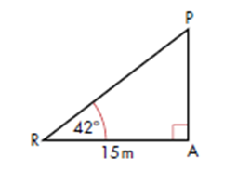Calculate the height of the pole. Give your answer to 3 significant figures. (3)

**Question 2**

Given that sin Ɵ = $\frac{\sqrt{3}}{4}$, find in surd form the possible values of cos Ɵ.

(3)

**Question 3**

The graph of *y* = sin *x* for $0≤x≤360°$ is shown below.

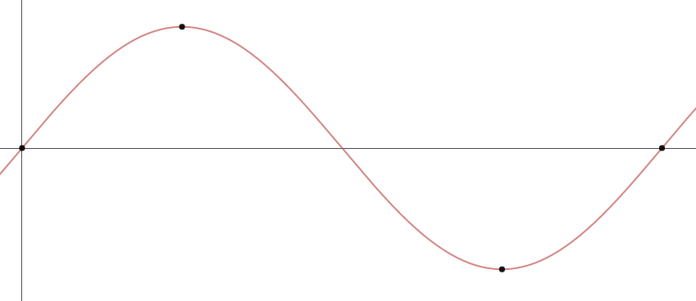

What are the coordinates of the 4 points labelled on the graph?

(………, ………)

(………, ………)

(………, ………)

(………, ………)

(4)

**Total / 10**

**10 Sine / Cosine Rule**

**Question 1**

This diagram shows a village green which is bordered by 3 straight roads AB, BC and AC. The road AC runs due North and the measurements are shown in metres.



(i) Calculate the bearing of B from C, giving your answer to the nearest 0.1o

(4)

(ii) Calculate the area of the village green.

(2)

**Question 2**

This diagram shows a logo ABCD. It is symmetrical about AC.

Find the length of AB and hence find the area of the logo



(4)

**Total / 10**

**11 Inequalities**

**Question 1**

Solve the inequality $x^{2}<3\left(x+6\right)$

**(3)**

**Question 2**

Solve the inequality $x^{2}>3x+4$

**(3)**

**Question 3**

A rectangle has length 3x cm and width (x+2) cm. The area of the rectangle is less than 90cm. Find the possible range of values for x.

**(4)**

Total / 10

**12 Algebraic proof**

**Question 1**

1. If n is a positive integer explain why the expression 2n + 1 is always an odd number.

**(1)**

1. Use algebra to prove that the product of two odd numbers is also odd.

**(4)**

**Question 2**

1. Prove that the sum of four consecutive whole numbers is always even.

**(3)**

1. Give an example to show that the sum of four consecutive number is not always divisible by 4.

**(2)**

Total / 10

**13 Vectors**

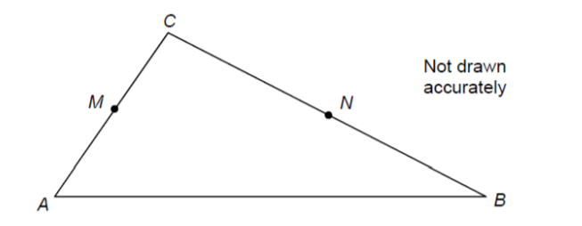Question 1

Triangle ABC has points M as the midpoints of AC

and point N such that BN:CN = 2:3

$\vec{AM}=a$

$\vec{AB}=2b$

1. Calculate $\vec{MN}$ giving your answer in its simplest form.

(4)

1. Are the lines MN and AB parallel? Show all of your working.

**(1)**

**Question 2**

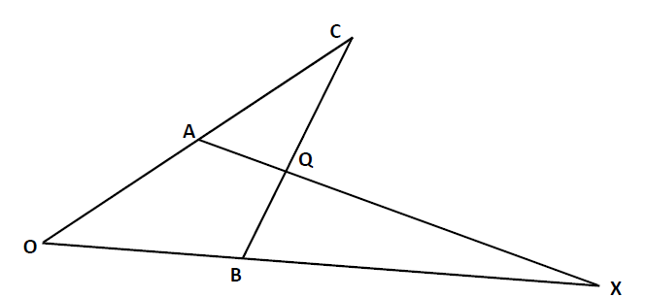

Diagram NOT drawn accurately

4**a**

4**b**

In the diagram

OA = 4**a** and OB = 4**b**

A is the midpoint of OC

BQ:QC = 1:2

Find, in terms of **a** and **b**, the vector that represents

(a) BC

**(1)**

(b) AQ

**(2)**

Question 3

Calculate the magnitude of vector a.

**a**

8

5

(2)

Total / 10

**14 Probability**

**Question 1**

Laura has 9 tins of soup in her cupboard, but all the labels are missing.

She knows that there are 5 tins of tomato soup and 4 tins of vegetable soup.

She opens three tins at random.

Work out the probability that she opens more tins of vegetable soup than tomato soup.

..............................................

**(4)**

**Question 2**

A summer camp runs coasteering and surfing classes.

50 children attend the camp

35 children do coasteering

10 children do both classes

2 children do neither class

1. Draw a venn diagram to represent this information

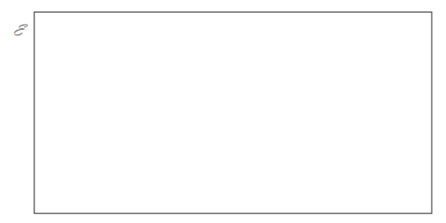

(2)

A child attending the summer camp is selected at random.

1. Find the probability that the child
2. did exactly one class

………………………………….. (2)

ii) did surfing, given that they did not do coasteering

…………………………………… (2)

Total / 10

**15 Statistics**

**Question 1**

The table and histogram show the lengths of some pythons.

|  |  |  |  |
| --- | --- | --- | --- |
| Length, cms | | | Frequency |
| 30 | < x ≤ | 40 | 20 |
| 40 | < x ≤ | 50 | 10 |
| 50 | < x ≤ | 70 | 50 |
| 70 | < x ≤ | 100 |  |
| 100 | < x ≤ | 150 |  |
|  |  | Total | 180 |

(a) Use the histogram to find the missing frequencies in the table

…………………………………

(2)

(b) Estimate the median python length.

…………………………………

(3)

**(Total 5 marks)**

**Question 2**

In France in 2007 25% of the population were under 21years old. 50% were under 36. The interquartile range of the ages was 30 years. The oldest person was 103 years old.

1. Show this information on a boxplot

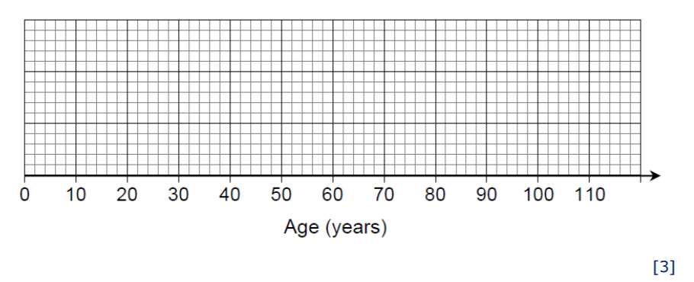

1. It is predicted that by 2040 the age distribution in France will have a lower quartile of 26 years, a median of 44 years and an upper quartile of 66 years.

Make two comments about the predicted change in the age distribution from 2007 to 2040.

Comment 1

Comment 2

(2)

**(Total 5 marks)**

Total / 10