National Extended

Certificate In

Sport

BTEC LEVEL 3

Year 11 – 12 Transition

(2022)

# COURSE INFORMATION

Course being studied:

BTEC Level 3 National Extended Certificate in Sport

## Mandatory units studied:

**Unit 1:** Anatomy and Physiology

**Unit 2:** Fitness Training and programming for Health, Sport and Well-being

**Unit 3:** Professional Development in the Sports Industry

These units are mandatory and are required to complete the course.

Additional unit required to complete the course

**Unit 7:** Practical Sports Performance

For this unit, you will be required to perform and be assessed practically in **2 sports**.

1 sport must be an individual sport and 1 sport must be a team sport.

Unit 1 and Unit 2 are externally assessed (exam) ~ worth 33% each.

Unit 3 and Unit 7 are internally assessed ~ worth 17% each.

The externally assessed units are written examinations.

The internally assessed units are a combination of videoed practical work and written coursework.

## Grading criteria

The criteria for each unit varies between a pass up to a distinction. Overall grade is worked out by combining the number of points awarded for each Unit grade. Distinction* can be achieved overall if you achieve a distinction in **all** of the units.

**Important information regarding mandatory units!**

You ***must pass*** all the mandatory units at a pass or above to complete the course.

Course Expectations

* 100% attendance to lessons.
* Excellent behaviour towards the learning environment.
* Good practical ability in 1 individual and 1 team sport – ***at least one*** of these should be played outside of school.
* Positive contributions to class discussions.
* Participate in presentations and work as a team when required.
* You **must** attend additional support sessions if required due to underperformance (for example to improve practical sport performance or level up coursework).
* Meeting coursework deadlines is **essential**.

# Assessment Expectations

* All learner work must be submitted on the given deadline day. If not the grade will be capped at pass level regardless of criteria.
* All leaners work needs to have the name and assignment title in the header and page numbers in the footer.
* All coursework **must** be your own work – any indication of plagiarism will be treated severely and may result in your work being marked ads a ‘FAIL’.   
  Any use of source material (eg BMI chart) or websites used to support your work must be correctly referenced.
* All learners need to have submitted their work with a signed declaration form, this form states that is your own work.
* For written examinations, you will be given at least 1 mock exam prior to the final exam – it is expected that you fully prepare for this exam as if it was your actual exam.

You will be starting the year in September studying Unit 2 - Fitness Training and programming for Health, Sport and Well-being.

**UNIT 2**

In this section learners explore client screening and lifestyle assessment, fitness training methods and fitness programming to support improvements in a client’s health and well-being.

Assessment Outcomes (that you will be judged against)

AO1 - Demonstrate knowledge and understanding of the effects of lifestyle choices on an individual’s health and well-being

AO2 - Apply knowledge and understanding of fitness principles and theory, lifestyle modification techniques, nutritional requirements and training methods to an individual’s needs and goals

AO3 - Analyse and interpret screening information relating to an individual’s lifestyle questionnaire and health monitoring tests

AO4 - Evaluate qualitative and quantitative evidence to make informed judgements about how an individual’s health and well-being could be improved

AO5 - Be able to develop a fitness training programme with appropriate justification

Learning Aims

There are 5 learning aims through which the course is delivered. This helps to break the module down into smaller sections to aid progress and learning.

A – Examine lifestyle factors and their effects in health and well-being

B – Understand the screening process for training programming

C – Understand programme-related nutritional needs

D – Examine training methods for different components of fitness

E – Understand training programme design

It is expected that you will complete the following tasks to ensure that you are fully prepared to meet the demands of the course in September.

Some useful websites to help you:

[www.nhs.uk/livewell](http://www.nhs.uk/livewell) (NHS website - healthy lifestyle)

[www.nutrition.org.uk](http://www.nutrition.org.uk) (Nutrition Foundation)

[www.bhf.org.uk](http://www.bhf.org.uk) (British Heart Foundation)

[www.cdc.gov](http://www.cdc.gov) (Government website – Centres of Disease Control and Prevention)

[www.bases.org.uk](http://www.bases.org.uk) (British Association of Sport and Exercise Sciences)

[www.eis2win.co.uk](http://www.eis2win.co.uk) (English Institute for Sport – improving athlete performance)

Task 1 – Healthy Lifestyle

Use the picture below and your own knowledge to identify some of the key factors that contribute to a healthy lifestyle. Write a list of these key words or phrases around the picture below – there is one written on for you to start you off.

**Exercise**

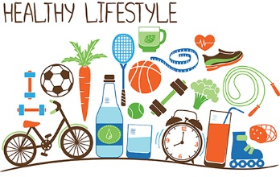

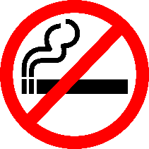

Task 2 – Exercise & Physical Activity

There is overwhelming scientific evidence to prove that people who exercise regularly are less likely to die early or suffer from chronic diseases.

***Part 1***

What are the government (Department of Health) recommendations for the amount of exercise people should do per week?

Children:

Adults:

Give an example of exercise that can be classed as ‘moderate’ or ‘vigorous’.

Moderate exercise =

Vigorous exercise =

***Part 2***

Research the benefits of exercise and physical activity. Categorise your responses in the table below under the following headings: Physical, Social, Economic and Psychological.

|  |  |  |  |
| --- | --- | --- | --- |
| Physical | Social | Economic | Psychological |
|  |  |  |  |
|  |  |  |  |
|  |  |  |  |
|  |  |  |  |

Choose 1 *benefit* from each category and explain ***WHY*** it helps to keep a person healthy.

Physical: ________________________________________________  
____________________________________________________________________________________________________________

Social: _________________________________________________  
____________________________________________________________________________________________________________  
Economic: _______________________________________________  
____________________________________________________________________________________________________________

Psychological: ____________________________________________  
____________________________________________________________________________________________________________

Task 3 – Balanced Diet

‘Diet’ refers to your typical food consumption, while ‘balanced diet’ is one that provides the correct amount of nutrients required by the body.

Identify key components of a balanced diet (pass).

Complete the following table to include the main components of a balanced, healthy diet and 2 examples of food sources for each one.

When deciding on a healthy or unhealthy food source, you can also consider the method of preparing and cooking foods.

|  |  |  |
| --- | --- | --- |
| Nutritional component | Food source – example HEALTHY | Food source – example UNHEALTHY |
| Carbohydrate |  |  |
| Protein |  |  |
| Fats |  |  |
| Vitamins  (eg: A, B, C, D) |  |  |
| Minerals  eg: Calcium  (dairy products) |  |  |
| Fluid |  |  |

Explain what a balanced, healthy diet looks like (merit)

Definition: ______________________________________________

____________________________________________________________________________________________________________

The ‘Eatwell Guide’ is a way in which the UK government (Public Health England) promotes a balanced diet.

It is made up of the following food groups:

* Starchy carbohydrates
* Fruit & veg
* Dairy & substitutes
* Protein products
* Oil & spreads

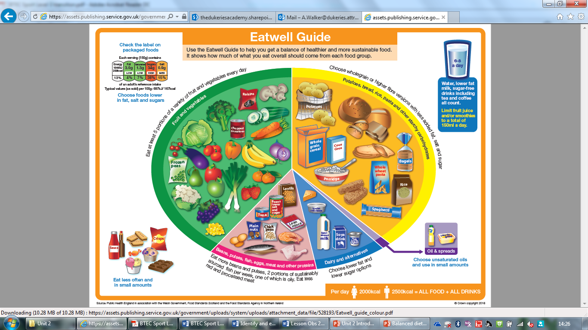This model represents the proportion of each food group that should be consumed to achieve a healthy, balanced diet.

Using the ‘Eatwell Guide’, explain what a healthy, balanced diet should consist of. Consider the proportion of each food group, as well as the food types. Can you say why they are important?

Fruit & Veg _____________________________________________  
__________________________________________________________________________________________________________________________________________________________________

Carbohydrates ___________________________________________  
__________________________________________________________________________________________________________________________________________________________________

Dairy products ___________________________________________  
__________________________________________________________________________________________________________________________________________________________________

Healthy proteins _________________________________________  
__________________________________________________________________________________________________________________________________________________________________

Fluid intake _____________________________________________  
______________________________________________________

Does the amount of calories you eat each day contribute to a healthy diet? What is the recommended daily calorie intake for men and women?

____________________________________________________________________________________________________________________________________________________________________________________________________________________________________________________________________________________________________________________________________

Give (at least) 3 examples of what you should try to avoid or limit in your diet.



Task 4 – Components of Fitness

For learning Aim D, you will need to know what the different components of fitness are and how we can train to improve them. The following task is designed to help you learn these and begin to think of ways you can train to improve in those areas.

Definitions to help you …………

***Physical fitness*** – focusing on the health-related aspects of fitness

***Skill-related fitness*** – fitness that allows the individual to perform an activity, task or sport (also known as motor fitness)

**A)**

Below is a list of the 11 components of fitness. Decide which component of fitness is ‘physical’ and which is ‘skill’ related. Write each one into the correct circle.

* agility, muscular endurance, body composition, coordination, power, speed, strength, reaction time, aerobic endurance, balance, flexibility.

Physical Skill

**B)** Research and give a correct definition for each component of fitness.

|  |  |
| --- | --- |
| Component | Definition |
|  |  |
|  |  |
|  |  |
|  |  |
|  |  |
|  |  |
|  |  |
|  |  |
|  |  |
|  |  |
|  |  |

**C)** Research different methods of training. Give **one** example of a method of training for each component of fitness – for some components, there will be a number of methods from which to choose.

In 2 or 3 sentences, summarise how you would complete/use this method.

Aerobic Endurance  
Method:

Strengths  
Method:

Muscular Endurance  
Method:

Flexibility  
Method:

Speed  
Method:

Agility  
Method:

Balance  
Method:

Coordination  
Method:

Reaction Time  
Method:

Power  
Method:

Note: there is no method of training specifically for improving body composition.

Why is that?