**The Bridge to A level**

**Problem Solving**

**Solutions**



**1 Solving quadratic equations**

**Question 1**

A number and its reciprocal add up to $\frac{26}{5}$.

Form and solve an equation to calculate the number.

$x+\frac{1}{x}=\frac{26}{5}$ (M1)

$x^{2}+1=\frac{26x}{5}$

$5x^{2}+5=26x$

$5x^{2}-26x+5=0$ (M1)

$\left(5x-1\right)\left(x-5\right)=0$

$x= \frac{1}{5} or 5$ so the number is 5 (A1)

………………………

**(3)**

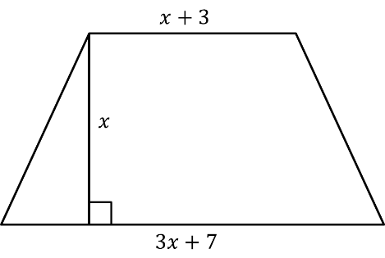**Question 2**

The diagram shows a trapezium.

Diagram **NOT** accurately drawn

All the measurements are in centimetres.

The area of the trapezium is 16 cm2.

1. Show that

Area

(A1)𝑎ONS

**(1)**

1. Work out the value of $x$ to 1 decimal place.

$x=\frac{-5±\sqrt{5^{2}-4×2×-16}}{2×2}$ (M1)

$$x= 1.842329219…$$

or $x=-4.342329219…$

$x=1.8$ (A1)

$x=$……………………… **(2)**

**Question 3**

Two numbers have a product of 44 and a mean of 7.5.

Use an algebraic method to find the numbers.

You must show all of your working.

$1st number:x then 2nd number: \frac{44}{x}$

$\frac{x+\frac{44}{x}}{2}=7.5$ (M1)

$x+\frac{44}{x}=15$

$x^{2}+44=15x$

$x^{2}-15x+44=0$ (M1)

$\left(x-11\right)\left(x-4\right)=0$ (M1)

$x=11 or 4 so the numbers are 11 and 4$ (A1)

………………………

**(4)**

Total / 10

**2 Changing the subject**

**Question 1**

The surface gravity of a planet is given by $g=\frac{GM}{r^{2}}$ where

M = Mass of the planet

r = radius of the planet

G = gravitational constant $=6.67x{10}^{-11}$

The surface gravity of Earth is 9.807m/s² and the mass of Earth is 5.98 x 1024kg.

Find the radius of Earth in kilometres correct to 3 significant figures.

$r=\sqrt{\frac{GM}{g}}$ M1

$r=\sqrt{\frac{6.67x{10}^{-11}x5.98x{10}^{24}}{9.807}}$ M1

r = 6377425.902m = 6380km A1 A1

(4)

**Question 2**

In a parallel circuit, the total resistance is given by the formula $\frac{1}{R}=\frac{1}{R_{1}}+\frac{1}{R_{2}}$

Make $R_{1}$ the subject of the formula

$$\frac{1}{R}=\frac{1}{R_{1}}+\frac{1}{R_{2}}$$

$R_{1}xR_{2}=RxR_{2}+{RxR}_{1}$ M1 Multiplying out denominators

$R_{1}xR_{2}- {RxR}_{1}= RxR_{2}$ M1 Collecting $R_{1}$ terms together

$R_{1}(R_{2}-R) = RxR_{2}$ M1 Factorising

$R_{1} = \frac{RxR_{2}}{(R_{2}-R)}$ A1

(4)

**Question 3**

**Show that $\frac{1}{\frac{1}{x}+1}=\frac{x}{x+1}$**

$\frac{1}{\frac{1}{x}+1}= \frac{1}{\frac{x+1}{x}}$

$=\frac{1}{1}÷\frac{x+1}{x}$ M1

$=\frac{1}{1}×\frac{x}{x+1}$

$= \frac{x}{x+1} as required$ A1

**(2)**

Total / 10

**3 Simultaneous equations**

**Question 1**

Sarah intended to spend £6.00 on prizes for her class but each prize cost her 10p more than expected, so she had to buy 5 fewer prizes.

Calculate the cost of each prize.

$Let x be no. of prizess \& y be the price of each prize$

$xy=600 => x=\frac{600}{y}$ (M1)

$\left(x-5\right)\left(y+10\right)=600$

$xy-5y+10x-50=600$ (M1)

$\frac{600y}{y}-5y+\frac{6000}{y}-50=600$ (M1)

$5y+50+\frac{6000}{y}=0$

${5y}^{2}+50y+6000=0$

$y^{2}+10y+1200=0$

$\left(y+40\right)\left(y-30\right)=0$ (M1)

$y is a price so y=30$

$Cost of each prize=y+10=40p$ (A1)

………………………

**(5)**

**Question 2**

Arthur and Florence are going to the theatre.

Arthur buys 6 adult tickets and 2 child tickets and pays £39.

Florence buys 5 adult tickets and 3 child tickets and pays £36.50.

Work out the costs of both adult and child tickets.

6A + 2C = 39 x3 18A + 6C = 117

5A + 3C = 36.50 x2 10A + 6C = 73 (M1 both correct)

Subtracting equations: 8A = 44 M1

A = 5.5

Substitute: (6x5.5)+2C = 39 M1

C = 3

Adult ticket = £5.50 A1

Child ticket = £3 A1

……………………

**(5)**

Total / 10

**4 Surds**

**Question 1**

Calculate the area of each shape giving your answers in the form $a+b√2$

**a)**

11-√2

5+√2

$$\left(11-\sqrt{2}\right)\left(5+\sqrt{2}\right)$$

$=55-5\sqrt{2}+11\sqrt{2}-2$ M1

$=53+6√2$ A1

**(2)**

5+√8

**b)**

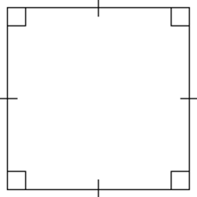

$\left(5+\sqrt{8}\right)\left(5+\sqrt{8}\right)=25+10\sqrt{8}+8$ M1

$=33+10\sqrt{8}$ M1

$$=33+10\sqrt{4}\sqrt{2}$$

$=11+20√2$ A1

(3)

Question 2

Colin has made several mistakes in his ‘simplifying surds’ homework. Explain his error and give the correct answer.

1. 

C1 for a valid explanation

A1 for 120

**(2)**

Question 3

The area of a triangle is 20cm³. The length of the base is √8cm. Work out the perpendicular height giving your answer as a surd in its simplest form.

$20=\frac{√8×x}{2}$

$40= √8×x$

$\frac{40}{\sqrt{8}}=x$ M1

$x=\frac{40}{\sqrt{8}}×\frac{\sqrt{8}}{\sqrt{8}}$

$=\frac{40\sqrt{8}}{8}$

$=5√8$ M1

$=10√2$ A1

(3)

Total / 10

**5 Indices**

**Question 1**

Lowenna says that ${27}^{-1/3}×{64}^{2/3}$ = 48

Is Lowenna correct? You must show all of your working.

${27}^{-1/3}= \frac{1}{∛27}=\frac{1}{3}$ M1

${64}^{2/3}{=(\sqrt[3]{64})}^{2}=4^{2}=16$ M1

$\frac{1}{3}×16= \frac{16}{3}≠5 so Lowenna is not correct$ A1A1

**(4)**

**Question 2**

Which one of these indices is the odd one out? Circle your answer and give reasons for your choice.

  

B1 for correct answer circled

C1 for correct explanation, with at least two indices evaluated

**(2)**

**Question 3**

Find values for a and b that make this equation work

 = 

a = 16 and b = 64 (A1) (note: other solutions possible)

**(1)**

**Question 4**

1. Write 25 as a power of 125

 (A1)

**(1)**

1. Write 4 as a power of 32

 (A1)

**(1)**

1. Write 81 as a power of 27

 (A1)

**(1)**

Total / 10

**6 Properties of Lines**

**Question 1**

1. (a) Write down the gradient of the line $2y-4x=5$. m = 2 (A1)

**(1)**

(b) Write down the equation of a line parallel to $3y=7-4x$.

*y =* -4*x/3* + *k* for any *k* (A1)

**(1)**

(c) Write down the equation of a line with gradient ½ and y-intercept of 6.

*y* = ½ *x* + 6 (A1)

**(1)**

**Question 2**

Here is the profile of the first half of a fell running race.

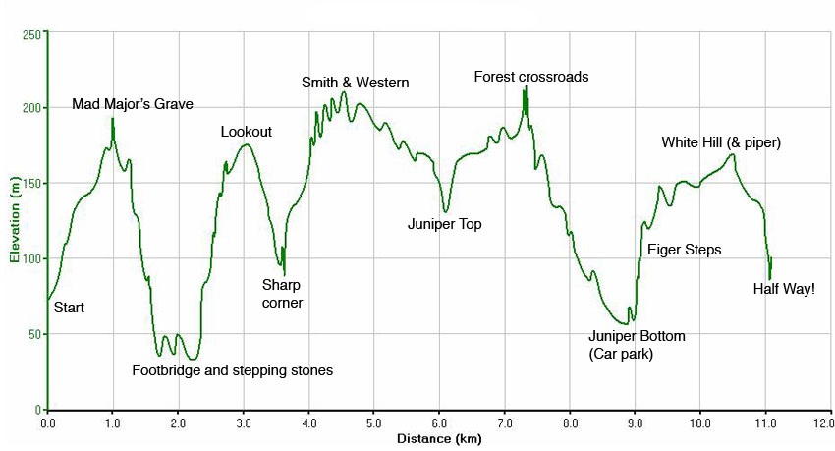

1. Work out the approximate gradient of the race from the start to Mad Major’s Grave

$\frac{up}{along}= \frac{195-75}{1000-0}$ (M1) accept approx. values m = 0.12 (A1)

**(2)**

(b) The most dangerous part of the race is from Mad Major’s Grave to the Footbridge. Why do you think this might be?

It is the steepest part of the course (and it is downhill) (C1)

**(1)**

(c) Work out an estimate for the average ascent for the first four uphill sections of the race.

Section 1 = $\frac{up}{along}= \frac{195-75}{1000}=0.12$ Section 2 = $\frac{up}{along}= \frac{175-30}{1000}=0.145$

Section 3 = $\frac{up}{along}= \frac{210-90}{1000}=0.12$ Section 4 = $\frac{up}{along}= \frac{220-130}{1000}=0.09$

Method to find four ascents using graph (M1)

Average of 0.12, 0.145, 0.12, and 0.09 = 0.11875 Km (A1)ft

**(2)**

**Question 3**

Here is a graph used to convert degrees Celsius (C) and degrees Fahrenheit (F).

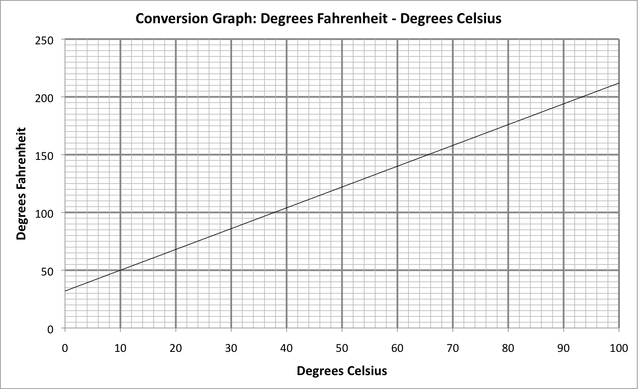

The equation of the straight line is given by *F* = *mC* + *a*

Calculate the values of *m* and *a*

Method to find gradient = $\frac{up}{along}=\frac{18}{10}$ (M1)

*m* = 1.8 or 9/5

*a* = 32 (A1) both correct

**(2)**

Total / 10

**7 Sketching curves**

**Question 1**

Sketch the graph of ${f\left(x\right)=x}^{2}+5x-6$, showing the co-ordinates of the turning point and the coordinates of any intercepts with the coordinate axes.

(x + 2.5)2 – 6.25 – 6 M1

(x + 2.5)2 – 12.25

(-2.5 , - 12.25)

B1 Correct shape, right way up

B1 Min point (-2.5, -12.25) marked

B1 -6 marked

B1 x=-6 and x=1 marked

**(5)**

**Question 2**

1. On the axes sketch the graph of *y* = $\frac{3}{x}$ showing the coordinates of the turning point and the coordinates of any intercepts with the coordinate axes.

*x*

*y*

*0*

Turning points (3,1) & (-3, -1) (M1)

Graph drawn in correct quadrants (A1)

**(2)**

1. On the axes sketch the graph of *y* = *x*3 - 5 showing the coordinates of the turning point and the coordinates of any intercepts with the coordinate axes.

*x*

*y*

*0*

Graph drawn in correct quadrants (A1)

Intercept *y* axes at (0, -5) (M1)

Intercept *x* axes at ($\sqrt[3]{5}$, 0) (M1)

(0,-5)

**(3)**

Total / 10

**8 Transformation of functions**

**Question 1**

Here is a sketch of f(x).

The coordinates of P are (0,-2)

Sketch the graphs after the following translations and reflections, and state the coordinates of P’:

1. g(x) = f(x) + 1

P’ = (0, -1)

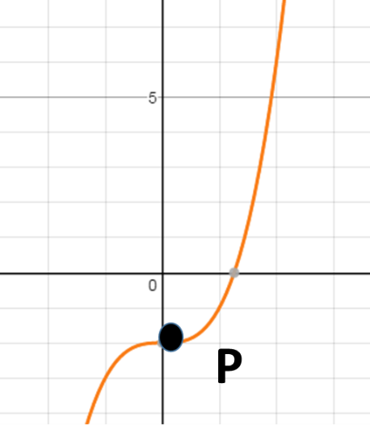

1. h(x) = f(x - 2)

P’ = (2, -2)

1. j(x) = -f(x)

P’ = (0, 2)

1. k(x) = f(-x)

P’ = (0, -2)

(4)

Question 2

The graph of $y=f\left(x\right)$ is shown below.

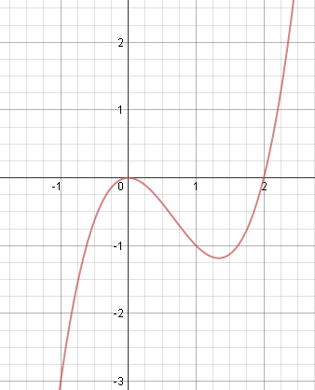

Below each sketch, write down the equation of the transformed graph

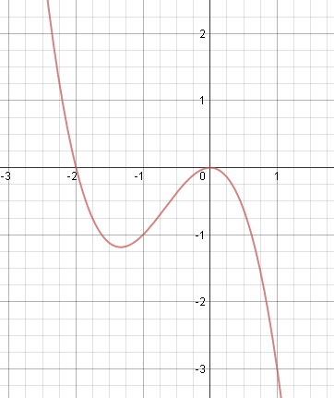 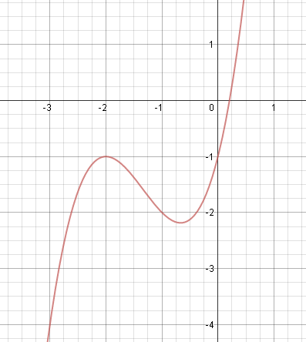

*y =*……………f(-x)…………B1…… *y =*…………f(x +2) – 1 B1

**(2)**

**Question 3**

The equation of a curve is $y=f\left(x\right)$ where $f\left(x\right)=x^{2}-4x+5$

C is the minimum point of the curve.

(a) Find the coordinates of C after the transformation.

f(x) = (x – 2)2 + 1

Before transformation C is (2,1) M1

After transformation C is (1,3) A1

(………, ………)

**(2)**

(b) Hence, or otherwise, determine if $f\left(x-3\right)-1=0$ has any real roots.

Give reasons for your answer.

Min point for f(x-3) – 1 is at (5, 0) M1

Hence it has a single, repeated root at x = 5 A1

**(2)**

Total / 10

**9 Pythagoras’ theorem and Trigonometric ratios**

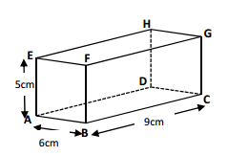

**Question 1**

ABCDEFGH is a cuboid

Diagram NOT drawn accurately

AE = 5cm

AB = 6cm

BC = 9cm

1. Calculate the length of AG. Give your answer correct to 3 significant figures.

AG = √(62 + 92 + 52 ) = = √142 = 11.9cm

..............................................

**(1)**

√142

G

A

C

5

θ

(b) Calculate the size of the angle between AG and the face ABCD.

Give your answer correct to 1 decimal place.

Use of Sin (M1)

Sinθ = 5 ÷ √142 = 0.41959 (M1 ft from (a) )

Θ = 24.8o (A1) **(3)**

**Question 2**

A piece of land is the shape of an isosceles triangle with sides 7.5m, 7.5m and 11m.

Turf can be bought for £11.99 per 5m2 roll.

How much will it cost to turf the piece of land?

√(7.52 - 5.52) = 5.10m length of land (M1)

Area of land = 11 x 5.1 ÷ 2 = 28.05m2  (M1)

Need to buy 6 rolls at £5.99 per roll Total cost = £35.94 (A1)

..............................................

**(3)**

**Question 3**

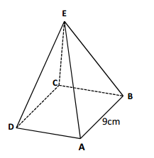

2.2m

Ben is 1.62m tall.

The tent he is considering buying is a square based pyramid.

2m

The length of the base is 3.2m.

The poles AE, CE, AE and BE are 2m long.

Ben wants to know if he will be able to stand up in the middle of the tent. Explain your answer clearly.

DB = √(2.22 + 2.22 ) = 3.1m (M1)

Height = √(22 – 1.552 ) = 1.5975m (M1)

Ben will be able to stand up in the tent (A1)

..............................................

**(3)**

Total / 10

**10 Sine / Cosine Rule**

**Question 1**

Plane A is flying directly toward the airport which is 20 miles away. The pilot notice a second plane, B, 45o to her right. Plane B is also flying directly towards the airport. The pilot of plane B calculates that plane A is 50o to his left. Based on that information how far is plane B from the airport? Give your answer to 3 significant figures.

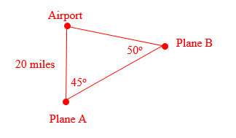

B1 use of Sine rule

$\frac{x}{Sin45 }= \frac{20}{Sin50}$ (M1)

$x= \frac{20}{Sin50}$ x Sin45 (M1)

x = 18.5 miles (A1)

................................

**(4)**

**Question 2**

Two ships, A and B, leave the same port at the same time.

Ship A travels at 35km/h on a bearing of 130o.

Ship B travels at 25km/h on a bearing of 120o.

Calculate how far apart the ships are after 1 hour.

Give your answer correct to two decimal places.

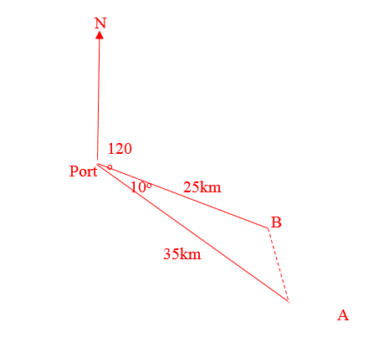AB2 = 252 + 352 – 2 x 25 x 35 x Cos10 (M1 sight of Cos10)

AB2 = 1850 – 1750Cos10

AB2 = 126.5864…(M1)

AB = 11.25km (A1)

................................

**(3)**

**Question 3**

A farmer has a triangular field. He knows one side measures 450m and another 320m.  The angle between these two sides measures 80o.  The farmer wishes to use a fertiliser that costs £3.95 per container which covers 1500m2. How much will it cost to use the fertiliser on this field?

Area of field = 0.5 x 450 x 320 x Sin80

Area of field = 70906m2 (to the nearest sq.m) (M1)

70906 ÷ 1500 = 47.27 (M1)

Needs to buy 48 containers

£3.95 x 48 = £189.60 (A1)

**(3)**

Total / 10

**11 Inequalities**

**Question 1**

A new cylindrical tube of snacks is being designed so that its height is 3 times its radius and its volume must be less than 20 times its radius.

Create an inequality and find possible values for the radius.

$πr^{2}.h<20r$ $h=3r$

π $r^{2}.3r<20r$

$3πr^{3}<20r$ (M1)

$3πr^{2}<20$ (M1)

$r^{2}<\frac{20}{3π}$

$r<\sqrt{\frac{20}{3π}}$ (A1)

Note; cannot have a negative length.

.……………………

**(3)**

**Question 2**

A base jumper is going to jump off a cliff that is $50m$ tall, the distance she travels downwards is given by the equation

$d=4.9t^{2} where t=time of flight$

$and d=distance travelled$

A video camera is set-up to film her between $20m$ and $10m$ above the ground.

Calculate the time period after the jumper jumps that filming taking place.

$20m above ground=30m downwards$

$10m above ground=40m downwards$

$So 30≤d≤40$ (M1)

$30≤4.9t^{2}≤40$

$\frac{30}{4.9}≤ t^{2}≤ \frac{40}{4.9}$ (M1)

$2.47≤t≤2.86 s$ (A1)

………………………

**(3)**

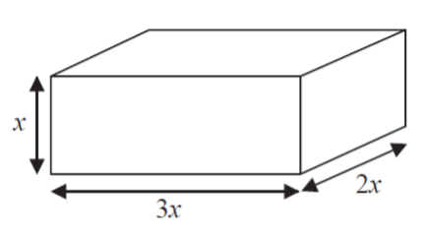**Question 3**

The total volume of the box is less than 1 litre.

Given that all lengths are in cm and that x is an integer,

Show that the longest side is less than 18cm.

Volume = 6x² M1

1l = 1000cm³ therefore 6x² < 1000 M1

x³ < 33.3

$\sqrt[3]{333}.3$ = 6.93 M1

X < 6.93 and an integer so a max value of 6 so 3x < 18 A1

**(4)**

Total / 10

**12 Algebraic proof**

**Question 1**

Katie chooses a two-digit number, reverses the digits, and subtracts the smaller number from the larger.

For example

42 – 24 = 18

She tries several different numbers and finds the answer is never a prime number.

Prove that Katie can never get an answer that is a prime number.

My numbers are

* Attempts to write an expression for the first number
* Writes the correct expression for the first number
* Writes the correct expression for the second number
* Attempts to subtract the expressions
* Simplifies the result
* Factorises
* Makes the statement

10a + b and 10b + a

10a + b – ( 10b + a )

= 10a – 10b + b – a

= 9a – 9b

= 9 ( a – b)

The answer is always a multiple of 9

(4)

**Question 2**

Here are the first 5 terms of an arithmetic sequence

1 6 11 16 21

Prove that the difference between the squares of any 2 terms is always a multiple of 5.

nth term = 5n-4

(n+1)th term = 5(n+1)-4 = 5n+1

Square nth term = (5n-4)² = 25n²+-40n+16

Square (n+1)th term = (5n+1)² = 24n²+10n+1

Difference = (24n²+10n+1) – (25n²+-40n+16) = 50n-15

Factorise = 5(10n-3) which is a multiple of 5

**(6)**

Total / 10

**13 Vectors**

**Question 1.**

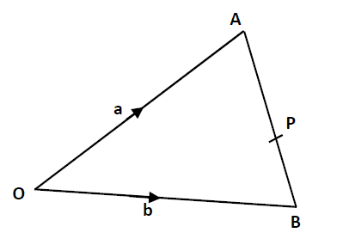

Diagram NOT drawn accurately

OAB is a triangle

OA = **a** and OB = **b**

1. Find the vector AB in terms of **a** and **b**

AB = -**a** + **b** or **b** - **a** (B1)

..............................................

**(1)**

P is the point on AB such that AP: PB = 3:2

1. Show that OP = $\frac{1}{5}$ (2**a** + 3**b**)
2. OP = OA + AP (M1) vector equation shown or implied in working
3. OP = **a** + $\frac{3}{5}$ (**b** – **a**) (M1) using equation from part (a)
4. OP = **a** + $\frac{3}{5}$**b** - $\frac{3}{5}$**a**
5. OP = $\frac{2}{5}$**a** + $\frac{3}{5}$**b** = $\frac{1}{5}$ (2**a** + 3**b**) (M1) simplified expression then factorisation clearly shown

..............................................

**(3)**

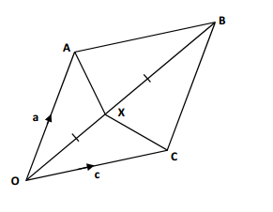**Question 2.**

OABC is a parallelogram.

X is the midpoint of OB

Diagram NOT drawn accurately

OA = **a** and OC = **c**

**(**a) Find the vector OX in terms of **a** and **c.**

OX = ½ (**a** + **c**) (B1)

..............................................

**(1)**

(b) Find the vector XC in terms of **a** and **c.**

XC = XO + OC = - ½ (**a** + **c**) + **c** (M1)

XC = - ½ **a** + ½ **c** or ½ (**c** – **a**) (A1)

..............................................

**(2)**

**Question 3**

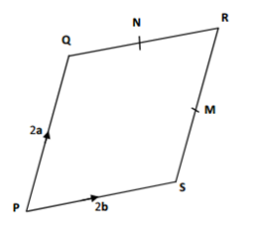

PQRS is a parallelogram.

M is the midpoint of RS

N is the midpoint of QR

Diagram NOT drawn accurately

PQ = 2**a**

PS = 2**b**

Use vectors to proof that the line segments SQ and MN are parallel.

SQ = -2**b** + 2**a** (M1)

MN = **a** – **b** (M1)

SQ = 2MN therefore parallel (A1)

**(3)**

Total / 10

**14 Probability**

**Question 1**

Max has an empty box.

He puts some red counters and some blue counters into the box.

The ratio of the number of red counters to the number of blue counters is 1 : 3.

Julie takes at random 2 counters from the box.

The probability that she takes 2 red counters is $\frac{19}{316}$.

How many red counters did Max put in the box?

For process to start to solve. E.g. use of *x* and 3*x* M1

To form fractions for each probability. E.g. $\frac{x}{4x}$ and $\frac{3x}{4x}$, $\frac{x-1}{4x-1}$ M1

Process to form equation e.g. $\frac{x}{4x}$ x $\frac{x-1}{4x-1}$ = $\frac{19}{316}$ M1

Process to eliminate fractions and reduce equation to linear form M1

E.g. 316*x* – 316 = 304*x* - 76

20 A1

(5)

**Question 2**

The Venn diagram shows the ice-cream flavours chosen by a group of 44 children at a party.

The choices are strawberry (S), choc-chip (C) and toffee (T).

A child is picked at random.

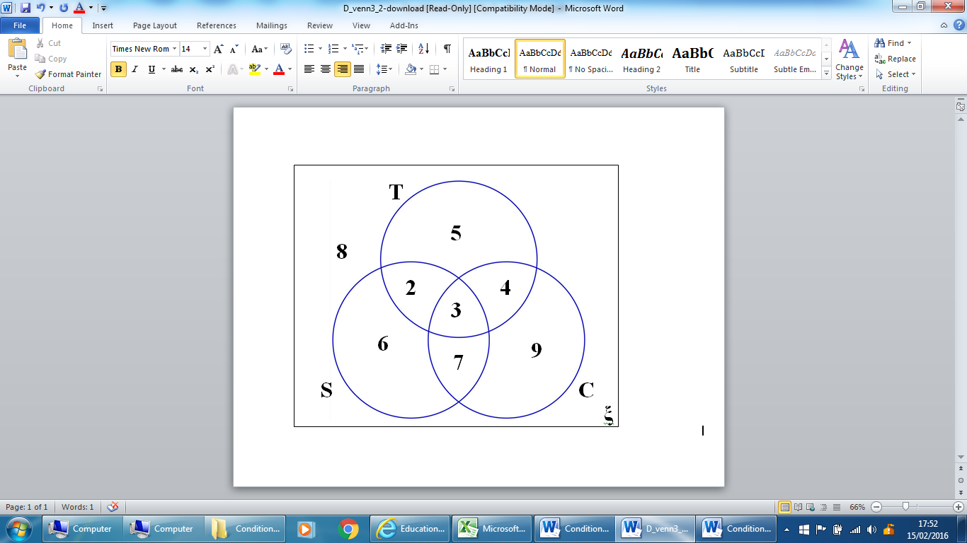

Work out :

1. P(S)

$\frac{18}{44}$ = $\frac{9}{22}$ A1 ............................................

**(1)**

(*b*) P(T U C│C)

$\frac{7}{23}$ M2

(Allow M1 for $\frac{7}{n}$ or $\frac{n}{23}$)

............................................

**(2)**

(*c*) P(C│S U T)

$\frac{14}{27}$ M2

(Allow M1 for $\frac{14}{n}$ or $\frac{n}{27}$)

............................................

**(2)**

Total / 10

**15 Statistics**

**Question 1**

The table and histogram show the weights of some snakes.

|  |  |  |  |  |  |
| --- | --- | --- | --- | --- | --- |
| Weight, grams | | | Frequency | Class Width | Freq. Density |
| 250 | < x ≤ | 300 | 60 | 50 | 1.2 |
| 300 | < x ≤ | 325 | 25 | 25 | 1.0 |
| 325 | < x ≤ | 350 | 40 | 25 | 1.6 |
| 350 | < x ≤ | 450 | 35 | 100 | 0.4 |
| 450 | < x ≤ | 600 | 40 | 150 | 0.2666666 |
|  |  | Total | 200 |  |  |

(a) Use the information to complete the histogram

Middle bar frequency = 40 class width = 25 frequncy density = 40/25 = 1.6 M1

Draw in scale M1

Draw rest of bars correctly A1

**(3)**

(b) Calculate an estimate for the median

200 snakes, median at 201/2 = 100.5th (condone 100th)

200 – (40 + 35 + (25))

25 / 1.6 = 15.625 M1

350 – 15.625 = (334.375)

……334 grams…………A1…………………

**(2)**

**Question 2**

Sarah played 15 games of netball. Here are the number of goals she scored in each game.

17 17 17 18 19 20 21 22 24 25 25 26 28 28 28

1. Draw a boxplot to show this information

Smallest value = 17

Largest value = 28

Median = 22

LQ = 18

UQ = 26 (M1M1 for calculations and A1 for graph)

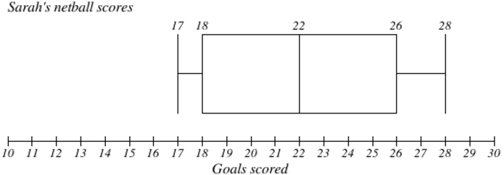

(3)

1. Lucy plays in the same 15 games of netball. The median number of points Lucy scores is 24. The interquartile range of these points is 10 and the range of these points is 17.

Who is the better player, Sarah or Lucy?

You must give a reason for your answer.

Comparison numbers for Sarah: 22, 8 and 11

Sarah is more consistent as she has a smaller IQR and smaller range. M1

Lucy scores more goals on average as she has a higher median. M1

**(2)**

Total / 10