A level Media Studies 2022

A guide to getting ready to start!

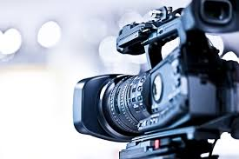

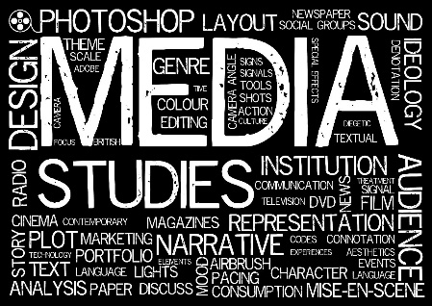**A Level Media Studies**

**Course Overview**

**Component 1:** Media Products, Industries and Audiences

**How will I be assessed**? Written examination: 2 hours 15 minutes

**What will I Study?** You will study media language, representation, media industries, audiences and media contexts

**How much of the qualification?** 35%

**Component 2:** Media Forms and Products in depth

**How will I be assessed**? Written examination: 2 hours 30 minutes

**What will I Study?** You will study Television in the Golden Age, Magazines, mainstream and alternative media and Media in the Online Age.

**How much of the qualification?** 35%

**Component 3:** Cross Media Production

**How will I be assessed**? Non-exam assessment

**What will I Study?** In year 1 you will learn the ICT skills needed to produce media in a variety of forms. You will produce an individual cross-media production based on two forms of media in response to a set brief.

**How much of the qualification?** 30%

**Course Expectations**

Com

* 5 A*-C (or equivalent) including English and Maths (4 / 5 in maths and English)
* An interest in the whole world around you- not just social media!
* 100% Attendance
* You will be expected to give individual presentations and take part in group activities.

**Key words**

[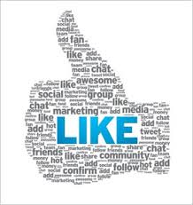](https://www.google.co.uk/imgres?imgurl=http://www.rickwhittington.com/blog/wp-content/thumbs-up-like.jpg&imgrefurl=http://www.rickwhittington.com/blog/pros-and-cons-of-four-major-social-media-platforms/&docid=IX2FQbpGFFcLLM&tbnid=shdUmY_j7uqGhM:&w=275&h=291&safe=strict&bih=660&biw=1366&ved=0ahUKEwjT_8vHlZ3NAhXDIsAKHSOiDHs4ZBAzCA8oDDAM&iact=mrc&uact=8)**You need to know these before we start!**

**Audience** – viewers, listeners and readers of a media text. A lot of media studies is concerned with how audience use texts and the effects a text may have on them.

**CGI** – Computer Generated Imagery, Refers to the (usually) 3-D effects that enhance all kinds of still and moving images, from text effects, to digital snow or fire, to the generation of entire landscapes.

**Consumer** – purchaser, listener, viewer or reader of media products.

**Context** – time, place or mind set in which we consume media products.

**Conventions** – the widely recognised way of doing things in particular genre.

**Genre** – the type or category of a media text, according to its form, style and content.

**Image** – a visual representation of something.

**Institutions** – The organisations which produce and control media texts such as the BBC, AOL Time Warner, News International.

**Media Platform** – nothing to do with trains, this refers to the different ways that media content is delivered, mainly via TV, laptop, tablet, smartphone, cinema, video/computer game, printed page etc. for instance the BBC delivers content via TV, laptop and mobile device, and also through printed publications. Most media organisations deliver their content via a multitude of platforms.

**Media product/Text** – a text that has been designed to be consumed by an audience. E.G a film, radio show, newspaper etc.

**Reader** – a member of the audience, someone who is actively responding to the text.

**SFX** – special effects or devices to create visual illusions.

**Stereotype** – representation of people or groups of people by a few characteristics eg hoodies, blondes

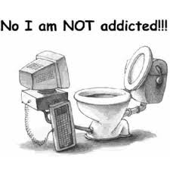

**Recommended Reading**

Don’t feel you need to read them all! They are just suggestions to help you interact more successfully with the media.

• WJEC/Eduqas MEDIA STUDIES for A Level Year 1 & AS

• FILM ART: AN INTRODUCTION – Bordwell & Thompson (McGraw-Hill)

[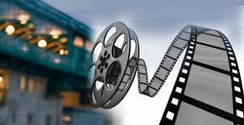](https://www.google.co.uk/imgres?imgurl=http://www.arkinfo.co.in/wp-content/themes/arkinfo/images/revolution/slider1-bg.jpg&imgrefurl=http://www.arkinfo.co.in/media-entertainment-2/&docid=psyH93d_22WMIM&tbnid=yE_-pUmSH1ZhLM:&w=1366&h=700&safe=strict&bih=660&biw=1366&ved=0ahUKEwjZ7qzyl53NAhVJIcAKHZJmCmoQMwhaKDIwMg&iact=mrc&uact=8)• READING TELEVISION – Fiske & Hartley (Methuen)

• UNDERSTANDING TELEVISION – Goodwin & Whannel (Routledge)

• UNDERSTANDING NEWS – Hartley (Routledge)

• THE NEWSPAPERS HANDBOOK – Keeble (Routledge)

• HOW TO READ A FILM – Monaco (Oxford)

• MEDIA STUDIES: TEXTS, INSTITUTIONS AND AUDIENCES – Taylor & Willis (Blackwell)

• THE MEDIA STUDENT’S BOOK (Branston, G, Stafford, R; 2006)

• STUDYING THE MEDIA (O’Sullivan, T; Dutton, B; Rayner, P; 2001)

• LEARNING THE MEDIA (Gutch, R, Wollen, T, Alvarado, M; 1987)

**So let’s get started!**

For each of the media products below, find an example and begin to analyse them.

|  |  |  |
| --- | --- | --- |
| **A 30 second film trailer** | | |
| **Name of Film** | **Genre of Film** | **3 things the trailer showed** |
|  |  |  |

|  |  |  |
| --- | --- | --- |
| **A TV advert** | | |
| **What was the advert for?** | **What time of day did you watch it?**  **What came directly before and after it?** | **3 things the advert showed** |
|  |  |  |

|  |  |  |
| --- | --- | --- |
| **The opening sequence (30 seconds) of a TV programme** | | |
| **What was the TV show?** | **What type of people usually watch it?** | **3 things the advert showed** |
|  |  |  |

|  |  |  |
| --- | --- | --- |
| **A magazine feature** | | |
| **What magazine did you choose?** | **What type of language is used?** | **3 things it contained** |
|  |  |  |

|  |  |  |
| --- | --- | --- |
| **A magazine advert** | | |
| **What magazine and advert did you choose?** | **What type of language/imagery is used?** | **3 things it contained** |
|  |  |  |

|  |  |  |
| --- | --- | --- |
| **A newspaper front page** | | |
| **What newspaper did you choose?** | **What is the headline?** | **3 things it contained** |
|  |  |  |

|  |  |  |
| --- | --- | --- |
| **A web page** | | |
| **What webpage is it?** | **What type of language/imagery did it used?** | **3 things it contained** |
|  |  |  |

**Analysing existing products**

In the same way that you deconstruct/analyse a text in History and English, you’ll need to do the same in Media.

Choose either a magazine front cover (or double page spread), a newspaper front cover or a website and analyse the page for the following:

• Who is the target audience? How do you know?

• What messages/attitudes are they encoding within the text? Why?

• How are people represented on the cover? What assumptions do you make about them based on body language, outfit, facial expressions, headline, etc.?

• What language techniques are used? What are the effects?

• What does the layout, colour scheme and font styles suggest? • Any other comments.