**Dukeries Academy A Level Transition Pack**

[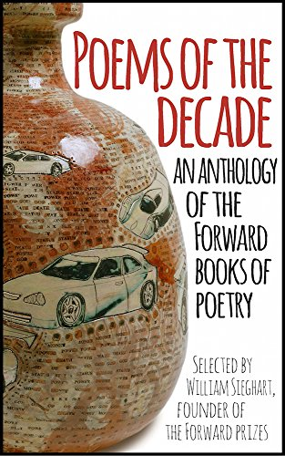](https://www.google.co.uk/url?sa=i&rct=j&q=&esrc=s&source=images&cd=&cad=rja&uact=8&ved=2ahUKEwjclLHi7dLbAhUCbRQKHVWXAkEQjRx6BAgBEAU&url=https://www.amazon.co.uk/Poems-Decade-Anthology-Forward-Poetry/dp/0571325408&psig=AOvVaw3OUiwQKDZp9nD8pyzINvig&ust=1529055495581710)

[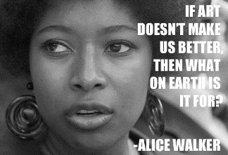](http://www.google.co.uk/url?sa=i&rct=j&q=&esrc=s&source=images&cd=&cad=rja&uact=8&ved=2ahUKEwiZrNyZ7tLbAhULPhQKHWa5DDQQjRx6BAgBEAU&url=http://legendsquotes.com/2016/05/28/alice-walker-quotes-4/&psig=AOvVaw2AoYJzhUj0p_DztrbCNxzD&ust=1529055612122862)[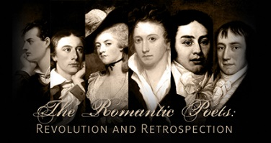](https://www.google.co.uk/url?sa=i&rct=j&q=&esrc=s&source=images&cd=&cad=rja&uact=8&ved=2ahUKEwjjp6nH7dLbAhVC1xQKHVZmAvcQjRx6BAgBEAU&url=https://hsp.arizona.edu/course/romantic-poets-revolution-and-retrospection&psig=AOvVaw2Xe3Ffzp7QYV0-w03chWbc&ust=1529055428919231)

[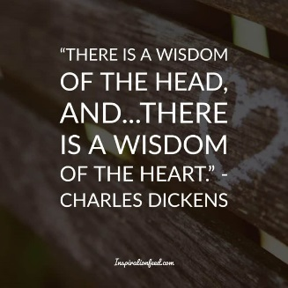](http://www.google.co.uk/url?sa=i&rct=j&q=&esrc=s&source=images&cd=&cad=rja&uact=8&ved=2ahUKEwjknvq879LbAhVHNxQKHehkAY8QjRx6BAgBEAU&url=http://inspirationfeed.com/charles-dickens-quotes/&psig=AOvVaw3brKDd8Qa4U-3zzZnw95wA&ust=1529055835720976)[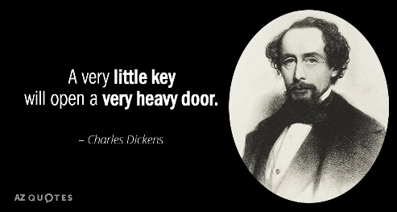](http://www.google.co.uk/url?sa=i&rct=j&q=&esrc=s&source=images&cd=&cad=rja&uact=8&ved=2ahUKEwjYruSG79LbAhXCuBQKHbs_ADUQjRx6BAgBEAU&url=http://www.azquotes.com/author/3947-Charles_Dickens&psig=AOvVaw3brKDd8Qa4U-3zzZnw95wA&ust=1529055835720976) 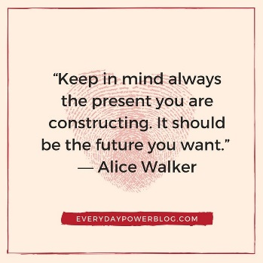

[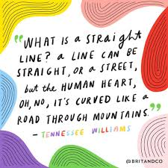](https://www.google.co.uk/url?sa=i&rct=j&q=&esrc=s&source=images&cd=&cad=rja&uact=8&ved=2ahUKEwiRz8bf8NLbAhUCaxQKHcmyD-EQjRx6BAgBEAU&url=https://www.pinterest.co.uk/pin/46936021100422554/&psig=AOvVaw24iD3J8_xfas26hxAseFvH&ust=1529056072589975)[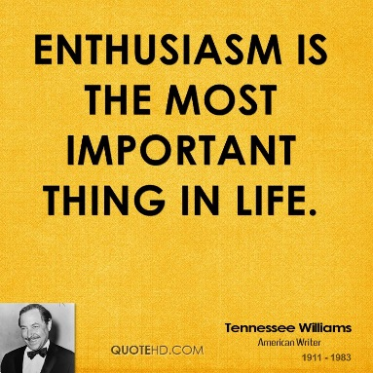](http://www.google.co.uk/url?sa=i&rct=j&q=&esrc=s&source=images&cd=&cad=rja&uact=8&ved=2ahUKEwiItKey8NLbAhVCcRQKHbp0CHoQjRx6BAgBEAU&url=http://www.quotehd.com/quotes/tennessee-williams-dramatist-enthusiasm-is-the-most-important-thing-in&psig=AOvVaw24iD3J8_xfas26hxAseFvH&ust=1529056072589975)

[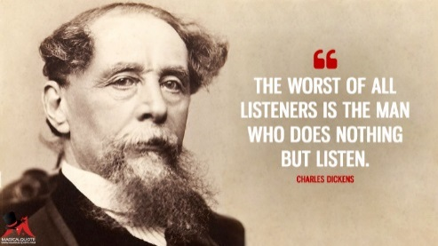](https://www.google.co.uk/url?sa=i&rct=j&q=&esrc=s&source=images&cd=&cad=rja&uact=8&ved=2ahUKEwjB8sza79LbAhUHbxQKHVnrBS0QjRx6BAgBEAU&url=https://www.magicalquote.com/authorname/charles-dickens/&psig=AOvVaw3brKDd8Qa4U-3zzZnw95wA&ust=1529055835720976)

[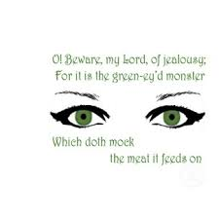](https://www.google.co.uk/url?sa=i&rct=j&q=&esrc=s&source=images&cd=&cad=rja&uact=8&ved=2ahUKEwjlmIiB8dLbAhVLXhQKHY4wDL4QjRx6BAgBEAU&url=https://www.pinterest.com.au/pin/415105290625206390/&psig=AOvVaw1EsLpBYBF4PXGhRTpRLb3m&ust=1529056349530888)

[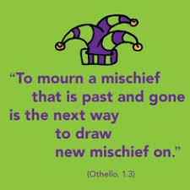](https://www.google.co.uk/url?sa=i&rct=j&q=&esrc=s&source=images&cd=&cad=rja&uact=8&ved=2ahUKEwjRmZWy8dLbAhVG0xQKHb_CBkIQjRx6BAgBEAU&url=https://quoteslifebook.com/browse/famous-quote-from-othello.html&psig=AOvVaw1EsLpBYBF4PXGhRTpRLb3m&ust=1529056349530888)

[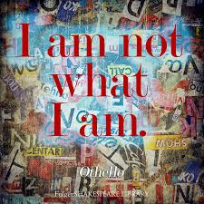](https://www.google.co.uk/url?sa=i&rct=j&q=&esrc=s&source=images&cd=&cad=rja&uact=8&ved=2ahUKEwjpmoGg8dLbAhWEOBQKHel9CFUQjRx6BAgBEAU&url=https://www.pinterest.ca/pin/313281717806158370/&psig=AOvVaw1EsLpBYBF4PXGhRTpRLb3m&ust=1529056349530888)

[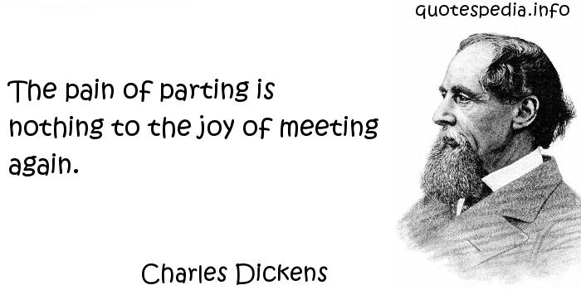](http://www.google.co.uk/url?sa=i&rct=j&q=&esrc=s&source=images&cd=&cad=rja&uact=8&ved=2ahUKEwjiw9aS9dLbAhUIvxQKHdkEAdAQjRx6BAgBEAU&url=http://www.golfian.com/102-interesting-charles-dickens-quotes-and-sayings-gallery/famous-quotations-from-charles-dickens/&psig=AOvVaw1gbEATiq1QeXe5MFMDng1V&ust=1529057466681468)

Dear Year 12,

Welcome back to English Literature. We are delighted that you have chosen to continue study in this fascinating subject and we are very excited to start our new course in September. We will be investigating novels, play scripts and poetry across a wide variety of themes and exploring how different writers try to convey their ideas about society and humanity. You will also have the opportunity to choose your own books to study in the coursework element and will investigate critical literary theory which will help you to investigate the deeper meaning of a text.

This booklet has a variety of tasks that might help you to transition in your further study. The poems that we are going to study are all in this booklet and you should bring this booklet with you in September.

We are sure that you are going to be intrigued and challenged during this interesting course and we are looking forward to exploring wider literature with you in September.

Yours sincerely,

Miss Summerfield and Miss Hughes

**Qualification at a glance**

We will be studying *Othello* by William Shakespeare, *A Streetcar Named Desire* by Tennessee Williams, the theme of childhood in H*ard Times* by Charles Dickens and The *Color Purple* by Alice Walker, a selection of modern poetry and a selection of poems from the Romantic Era, as well as a collection of other poems to prepare for the Unseen Poetry component. You will also complete an essay about two books of your choice as your coursework component.

**Component 1: Drama *Paper code: 9ET0/01**

**qualification**

**Paper 1**

**We will study the following texts:**

● Othello – William Shakespeare.

● critical essays related to their selected Shakespeare play. You will be given a booklet called *Shakespeare: A Critical Anthology – Tragedy* and I will share additional resources via Edmodo.

A Streetcar Named Desire – Tennessee Williams

**Overview of assessment**

● Written examination, lasting 2 hours and 15 minutes.

● Open book – clean copies of the drama texts can be taken into the

examination. The Critical Anthology **must not** be taken into the examination.

● Total of 60 marks available – 35 marks for Section A and 25 marks for

Section B.

● Section A – Shakespeare: **one** essay question, incorporating ideas from wider

critical reading (AO1, AO2, AO3, AO5 assessed).

● Section B – A Streetcar Named Desire: **one** essay question (AO1, AO2, AO3 assessed).

**Component 2: Prose *Paper code: 9ET0/02**

**We will also study texts for Paper 2 Literature. We will be studying the presentation of childhood in The Color Purple by Alice Walker and Hard Times by Charles Dickens.**

**Overview of assessment**

● Written examination, lasting 1 hour.

● Open book – clean copies of the prose texts can be taken into the

examination.

● Total of 40 marks available.

● Students answer **one** comparative essay question from a choice of **two** on

the theme of childhood in The Color Purple and Hard Times (AO1, AO2, AO3, AO4 assessed).

**Component 3: Poetry *Paper code: 9ET0/03**

**We will also study poetry for Paper 3. We will be studying both modern poetry and poetry from the Romantic period.**

**Overview of assessment**

● Written examination, lasting 2 hours and 15 minutes.

● Open book – clean copies of the poetry texts can be taken into the

examination.

● Total of 60 marks available – 30 marks for Section A and 30 marks for

Section B.

● Two sections: students answer **one** question from a choice of **two**, comparing

an unseen poem with a named poem from their studied contemporary text

and **one** question from a choice of **two** on their studied movement/poet.

● Section A – Poems of the Decade and Unseen Poetry: **one** comparative essay question on an unseen modern poem written post-2000 and one named poem from the

studied contemporary text (AO1, AO2, AO4 assessed).

● Section B – Poetry from the Romantic Era: **one** essay question (AO1,

AO2, AO3 assessed).

You will also write a coursework essay based on texts of your choice.

[](https://www.google.co.uk/url?sa=i&rct=j&q=&esrc=s&source=images&cd=&cad=rja&uact=8&ved=2ahUKEwj-mYS3ntPbAhWLCsAKHY0LCQQQjRx6BAgBEAU&url=https://www.youtube.com/watch?v=VquaXezUv78&psig=AOvVaw341Mfpbg0TMyZhoLPQzEQl&ust=1529068562508865)[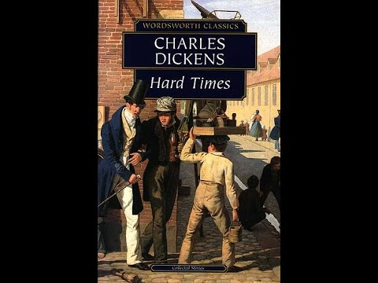](https://www.google.co.uk/url?sa=i&rct=j&q=&esrc=s&source=images&cd=&cad=rja&uact=8&ved=&url=https://www.youtube.com/watch?v=AqPYBgLZQtk&psig=AOvVaw2WIZ3oBpIcY2w9g5wf2wBO&ust=1529060021036139)[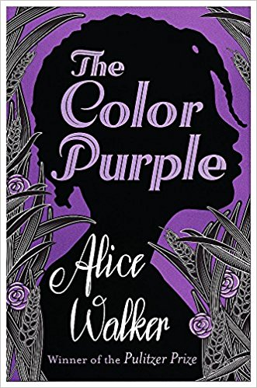](https://www.google.co.uk/url?sa=i&rct=j&q=&esrc=s&source=images&cd=&cad=rja&uact=8&ved=2ahUKEwj9qYO9_tLbAhVEzRQKHczEC60QjRx6BAgBEAU&url=https://www.amazon.co.uk/Color-Purple-Alice-Walker/dp/1780228716&psig=AOvVaw3Pk4gjhZQPpZ4drZtpZKr-&ust=1529059984806731)

**Autumn Term:**

We will start our studies by looking at *The Color Purple* by Alice Walker and *Hard Times* by Charles Dickens, considering the theme of childhood.

If you have your own copies of the text, you can highlight key quotes and annotate the book in class. You can also come and ask to loan a copy from us, or from the library but obviously you can’t then write in them. Hard Times is available for free online if you use this link - *https://www.pagebypagebooks.com/Charles_Dickens/Hard_Times/*

It is excellent preparation for your course to read both of these texts so that you have a good understanding of the storyline before we analyse them in depth.

I have also attached some questions to consider when reading the books.

CLOSE READING TASKS

1. How do the two writers develop sympathy for Celie and Louisa in the presentation of their childhood?
2. How are gender stereotypes and behaviours outlined in the two texts?
3. To what extent do the writers suggest that trauma in childhood dooms the person to unhappiness?
4. What is the role of religion in the two texts?
5. Who are the villains and heroes in the two texts?
6. Which characters do you like the most and why?
7. Which of the two texts do you prefer and why?
8. Can you find ten quotes in each text that you think are important when exploring ideas about childhood?
9. Do either of the texts have happy endings?
10. Conduct some research into the context of the writers and the time period in which the book is written and in which the book is set.

**[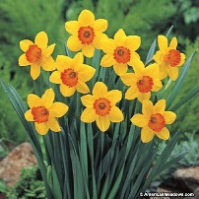](https://www.google.co.uk/url?sa=i&rct=j&q=&esrc=s&source=images&cd=&cad=rja&uact=8&ved=2ahUKEwjY2K6fntPbAhWhCsAKHR5wC8MQjRx6BAgBEAU&url=https://www.americanmeadows.com/flower-bulbs/daffodil-flower-bulbs/daffodil-bulbs-scarlet-ohara&psig=AOvVaw2aBVIdhpdPKZAYAMjmrFSi&ust=1529068510714197)Spring Term** [](https://www.google.co.uk/url?sa=i&rct=j&q=&esrc=s&source=images&cd=&cad=rja&uact=8&ved=2ahUKEwjT4JvFndPbAhXoIsAKHZgNCmUQjRx6BAgBEAU&url=https://itunes.apple.com/gb/app/magnifying-glass-with-light/id406048120?mt=8&psig=AOvVaw3D5GOZEkdlj9vQoW94OwrN&ust=1529068324369546)

In the Spring term, we will investigate play scripts by a close investigation of William Shakespeare’s Othello and Tennessee Williams A Streetcar Named Desire.

[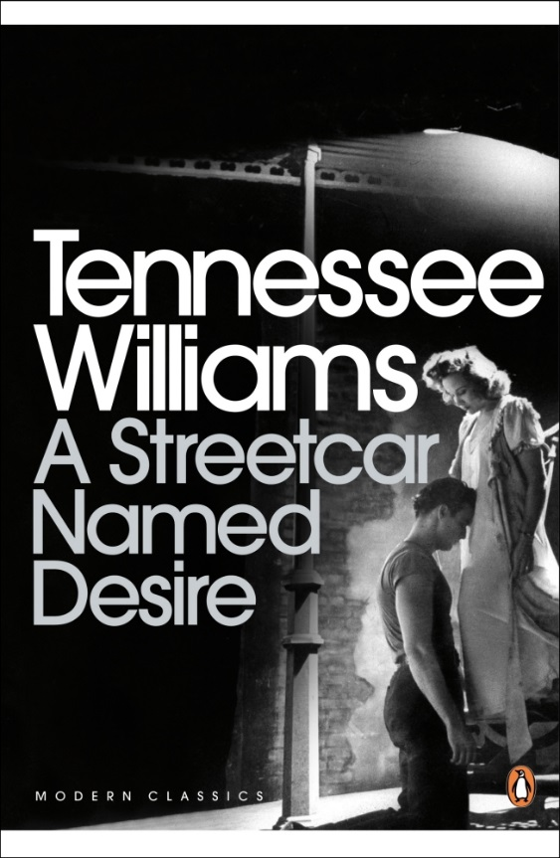](https://www.google.co.uk/url?sa=i&rct=j&q=&esrc=s&source=images&cd=&cad=rja&uact=8&ved=2ahUKEwiWrrvLotPbAhVqAcAKHXcvA6gQjRx6BAgBEAU&url=https://www.penguin.co.uk/books/57648/a-streetcar-named-desire/&psig=AOvVaw0ZPWT5ARItjPnCwDkmjd6b&ust=1529069635600320)[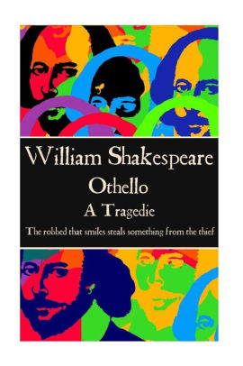](https://www.google.co.uk/url?sa=i&rct=j&q=&esrc=s&source=images&cd=&cad=rja&uact=8&ved=2ahUKEwiw6eKfotPbAhVIBMAKHWcgCY8QjRx6BAgBEAU&url=https://www.barnesandnoble.com/w/william-shakespeare-othello-william-shakespeare/1123854696&psig=AOvVaw3lWhLe9txxePBufK2cF9kh&ust=1529068748209768)

Othello is available for free online at No Fear Shakespeare. There are also multiple versions of the play on YouTube. You can loan a copy of A Streetcar Named Desire from the English Department if you wish.

[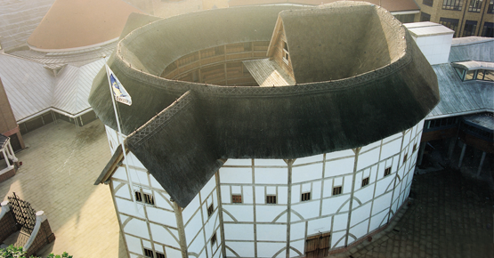](http://www.google.co.uk/url?sa=i&rct=j&q=&esrc=s&source=images&cd=&cad=rja&uact=8&ved=2ahUKEwisibfgptPbAhVJVsAKHcjGAsYQjRx6BAgBEAU&url=http://www.shakespearesglobe.com/about-us&psig=AOvVaw2QveLPcXVVpVAFnPmN5tuj&ust=1529070796456615)

CLOSE READING TASKS

1. How does Shakespeare create an effective villain in Iago?
2. How are gender stereotypes and behaviours outlined in the two texts?
3. How is racism shown in the two texts?
4. How are stage directions used to underline ideas in the text?
5. Do you feel sympathy for any of the characters and why?
6. How important is setting in each play?
7. Which of the two texts do you prefer and why?
8. Can you find ten quotes in each text that you think are important when exploring ideas about masculinity?
9. How do you feel about the ending of the two texts?
10. Conduct some research into the context of the writers and the time period in which the book is written and in which the book is set.

[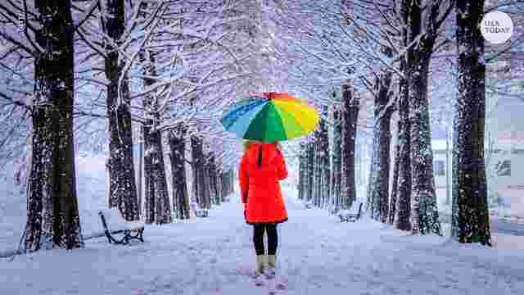](https://www.google.co.uk/url?sa=i&rct=j&q=&esrc=s&source=images&cd=&cad=rja&uact=8&ved=2ahUKEwjW6MaCm93bAhWJxRQKHSgTBccQjRx6BAgBEAU&url=https://www.usatoday.com/story/weather/2017/11/09/la-nina-here-what-does-mean-our-winter/847621001/&psig=AOvVaw0cZwxT0CdlssQ4JHaYRO43&ust=1529411235761828)

**Winter Term:**

This term we will study both modern poetry and poetry from the Romantic Era, as well as preparing you to tackle Unseen Poetry. Paper Three asks you to compare a taught poem from our Poetry of the Decade Anthology, which you can access on Edmodo and print off to use in class, with an Unseen modern poem with a similar theme.

You are also asked to compare one of the Romantic Era poems with another Romantic Era poem of your choice across an over-arching theme. You will be taught all of the Romantic Era Anthology poems in class and you can download that PDF on Edmodo as well. Full lists of both poems are included in this booklet.

The tasks that follow will help you to start to analyse the poems that we are going to look at in class and I will also share some videos, tasks and questions on Edmodo over the summer should you wish to have a head start in your studies. I would strongly advise that you at least read all of the poems prior to reaching this part of your course.

[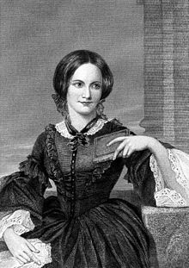](https://www.google.co.uk/url?sa=i&rct=j&q=&esrc=s&source=images&cd=&cad=rja&uact=8&ved=&url=https://fr.wikipedia.org/wiki/Charlotte_Bront%C3%AB&psig=AOvVaw0O1f6yhL9zSeuCnl2Zp9AD&ust=1529412254448722)[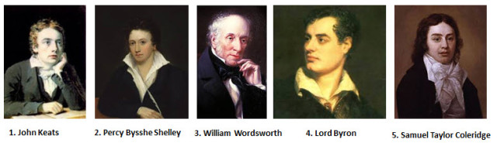](https://www.google.co.uk/url?sa=i&rct=j&q=&esrc=s&source=images&cd=&cad=rja&uact=8&ved=2ahUKEwifjsubm93bAhVCWhQKHVN7CC8QjRx6BAgBEAU&url=https://n2poetry.com/2017/06/25/so-you-think-you-know-the-romantic-poets-test-yourself/&psig=AOvVaw1gAsX6eueKDaKkm_9dyB2B&ust=1529411293078128)

Emily Bronte

**Post-2000 Specified Poetry**

***Poems of the Decade: An Anthology of the Forward Books of Poetry 2002–2011 (Faber and Faber, 2015) ISBN 978-0571325405***

|  |
| --- |
|  |
| **Eat Me Patience Agbabi** |
|  |
| **Chainsaw Versus the Pampas Grass Simon Armitage** |
|  |
| **Material Ros Barber** |
|  |
| **History John Burnside** |
|  |
| **An Easy Passage Julia Copus** |
|  |
| **The Deliverer Tishani Doshi** |
|  |
| **The Lammas Hireling Ian Duhig** |
|  |
| **To My Nine-Year-Old Self Helen Dunmore** |
|  |
| **A Minor Role U A Fanthorpe** |
|  |
| **The Gun Vicki Feaver** |
|  |
| **The Furthest Distances I’ve Travelled Leontia Flynn** |
|  |
| **Giuseppe Roderick Ford** |
|  |
| **Out of the Bag Seamus Heaney** |
|  |
| **Effects Alan Jenkins** |
|  |
| **Genetics Sinéad Morrissey** |
|  |
| **From the Journal of a Disappointed Man Andrew Motion** |
|  |
| **Look We Have Coming to Dover! Daljit Nagra** |
|  |
| **Please Hold Ciaran O’Driscoll** |
|  |
| **On Her Blindness Adam Thorpe** |
|  |
| **Ode on a Grayson Perry Urn Tim Turnbull** |

**Close Reading Tasks:**

1. Which poem do you like the most and why?
2. Which poets express ideas that you agree with completely? Are there any of the poets whose ideas you strongly disagree with and why?
3. Can you comment on the structure of the poems? Why do you think that this structure has been used?
4. Can you PEACOWS your favourite three lines from each of the poems? Why do those lines resonate with you?
5. Many of the poems express strong emotions. Which poems do this and what techniques do they use?
6. Can you find out more about any of the featured poets? Can you find other poems by them that you enjoy?
7. Do you prefer modern or older poems? Why?
8. Can you think of any song lyrics that express similar ideas to those expressed by each poet? What techniques do they use to do this? Can you compare a few lines from the poem and the song?
9. Some of the poems have strong visual imagery running through them. Can you attach images to particular lines as an aide memoire?

10. Can you answer the following essay question for any of the Poems of the Decade? How does the poet express their ideas about society and what techniques do they use to do so?

[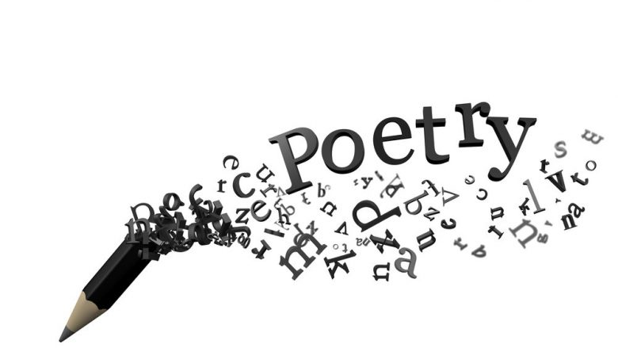](https://www.google.co.uk/url?sa=i&rct=j&q=&esrc=s&source=images&cd=&cad=rja&uact=8&ved=2ahUKEwjF6dCqmd3bAhVDnRQKHX54AlYQjRx6BAgBEAU&url=https://telegrafi.com/urdhnimet-e-poezis/&psig=AOvVaw0J4qJNjNXxjNHJWjg9BWd1&ust=1529410787615492)

|  |
| --- |
| Songs of Innocence: Holy Thursday William Blake |
|  |
| Songs of Experience: Holy Thursday William Blake |
|  |
| Songs of Experience: The Sick Rose William Blake |
|  |
| Songs of Experience: The Tyger William Blake |
|  |
| Songs of Experience: London William Blake |
|  |
| Lines Written in Early Spring William Wordsworth |
|  |
| Lines Composed a Few Miles above |
| Tintern Abbey William Wordsworth |
|  |
| Ode: Intimations of Immortality William Wordsworth |
|  |
| The Rime of the Ancient Mariner Samuel Taylor Coleridge |
|  |
| Lines Inscribed upon a Cup Formed George Gordon, Lord Byron |
| from a Skull |
|  |
| Fare Thee Well George Gordon, Lord Byron 211 |
|  |
| So We’ll Go no more A Roving George Gordon, Lord Byron 211 |
|  |
| On This Day I Complete My George Gordon, Lord Byron 211 |
| Thirty-Sixth Year |
|  |
| ‘The cold earth slept below’ Percy Bysshe Shelley |
|  |
| *Stanzas Written in Dejection, near* Percy Bysshe Shelley |
| *Naples* |
|  |
| Ode to the West Wind Percy Bysshe Shelley |
|  |
| The Question Percy Bysshe Shelley |
|  |
| Ode to a Nightingale John Keats |
|  |
| Ode on a Grecian Urn John Keats |
|  |
| To Autumn John Keats |
|  |
| Ode on Melancholy John Keats |
| Sonnet on the Sea |
| To a Wreath of Snow Emily Brontë |
|  |
| R. Alcona to J. Brenzaida Emily Brontë |
|  |
| Julian M. and A.G Rochelle Emily Brontë |
|  |
| Last Lines Emily Brontë |

**Prescribed poetry from the Romantic Era**

**Close Reading Tasks for the Romantic Era poetry:**

1. Which poem do you like the most and why?
2. Which poets express ideas that you agree with completely? Are there any of the poets whose ideas you strongly disagree with and why?
3. Can you comment on the structure of the poems? Why do you think that this structure has been used?
4. Can you PEACOWS your favourite three lines from each of the poems? Why do those lines resonate with you?
5. What styles, structures and ideas do you notice across the Romantic Era poems?
6. Can you find out more about any of the featured poets? Can you find other poems by them that you enjoy?
7. Art work from the same period had a lot of influence over the Romantic poets. Can you find any examples of artwork from the period that echo the poems that you have read?
8. What do you notice about the use of language in Romantic Era poetry? Are there any recurring semantic or lexical fields?
9. Some of the poems have strong visual imagery running through them. Can you attach images to particular lines as an aide memoire?

10. Can you answer the following essay question for any of the Poems of the Decade? How is visual imagery used in the poem to express deeper ideas about the nature of society?

[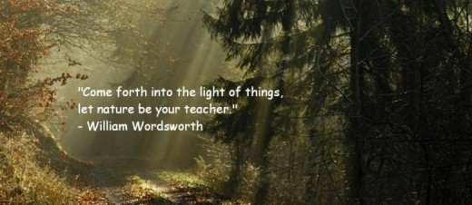](https://www.google.co.uk/url?sa=i&rct=j&q=&esrc=s&source=images&cd=&cad=rja&uact=8&ved=2ahUKEwjau__KoN3bAhXFbRQKHX7RDL4QjRx6BAgBEAU&url=https://theredstockingschronicleblog.wordpress.com/2017/03/08/literary-essay-text-and-context-the-romantic-age-and-its-poets/&psig=AOvVaw0yM5enm74KZ84cfUcd0IK_&ust=1529412721983040)