The Bridge to A level

Diagnosis


1 Solving quadratic equations

Question 1

Solve x2 + 6x + 8 = 0

(2)

Question 2

Solve the equation y² – 7y + 12 = 0

Hence solve the equation x⁴ – 7x² + 12 = 0

(4)

Question 3

(i) Express x² – 6x + 2 in the form (x-a)² – b

(3)

(ii) State the coordinates of the minimum value on the graph of y = x² – 6x + 2

(1)

Total / 10

2 Changing the subject

Question 1

Make v the subject of the formula E = $\frac{1}{2}$ mv²

(3)

Question 2

Make r the subject of the formula V = $\frac{4}{3}$ Π r²

(3)

Question 3

Make c the subject of the formula P = $\frac{C}{C+4}$

(4)

Total / 10

3 Simultaneous equations

Question 1

Find the coordinates of the point of intersection of the lines y = 3x + 1 and x + 3y = 6

(3)

Question 2

Find the coordinates of the point of intersection of the lines 5x + 2y = 20 and y = 5 – x

(3)

Question 3
Solve the simultaneous equations
x² + y² = 5
y = 3x + 1

(4)

Total / 10

4 Surds

Question 1

- Simplify (3 + $\sqrt{2}$)(3 - $\sqrt{2}$ )

(2)

(ii) Express $\frac{1+ \sqrt{2} }{3 - \sqrt{2} }$ in the form a + b$\sqrt{2}$ where a and b are rational

(3)

Question 2

(i) Simplify 5$\sqrt{8}$ + $4\sqrt{50}$ . Express your answer in the form a $\sqrt{b}$ where a and b are integers and b is as small as possible.

(2)
(ii) Express $\frac{\sqrt{3} }{6 - \sqrt{3} }$ in the form p + q$\sqrt{3}$ where p and q are rational

(3)

Total / 10

5 Indices

Question 1

Simplify the following

(i) a⁰

(1)
(ii) a⁶ ÷ a⁻²

(1)
(iii) (9a⁶b²)^{-0.5}

(3)

Question 2

(i) Find the value of ($\frac{1}{25}$) ^{-0.5}

(2)
(ii) Simplify $\frac{{\left(2x^{2}y^{3}z\right)}^{5}}{4y^{2}z}$

(3)

Total / 10

6 Properties of Lines

Question 1

A (0,2), B (7,9) and C (6,10) are three points.

(i) Show that AB and BC are perpendicular

(3)
(ii) Find the length of AC

(2)

Question 2

Find, in the form y = mx + c, the equation of the line passing through A (3,7) and B (5,-1).

Show that the midpoint of AB lies on the line x + 2y = 10

(5)

Total / 10

7 Sketching curves

Question 1
In the cubic polynomial f(x), the coefficient of x³ is 1. The roots of f(x) = 0 are -1, 2 and 5.

Sketch the graph of y = f(x)

(3)

Question 2
Sketch the graph of y = 9 – x²

(3)

Question 3
The graph below shows the graph of y = $\frac{1}{x}$

On the same axes plot the graph of y = x² – 5x + 5 for 0 ≤ x ≤ 5

(4)

Total / 10

8 Transformation of functions

Question 1

The curve y = x² – 4 is translated by ( $\begin{matrix}2 \\ 0\end{matrix}$ )
Write down an equation for the translated curve. You need not simplify your answer.
(2)

Question 2
This diagram shows graphs A and B.

- State the transformation which maps graph A onto graph B

(2)
(ii) The equation of graph A is y = f(x).

Which one of the following is the equation of graph B ?

y = f(x) + 2 y = f(x) – 2 y = f(x+2) y = f(x-2)

y = 2f(x) y = f(x+3) y = f(x-3) y = 3f(x)
(2)

Question 3
(i) Describe the transformation which maps the curve y = x² onto the curve y = (x+4)²
(2)
(ii) Sketch the graph of y = x² – 4
(2)

Total / 10
9 Trigonometric ratios

Question 1
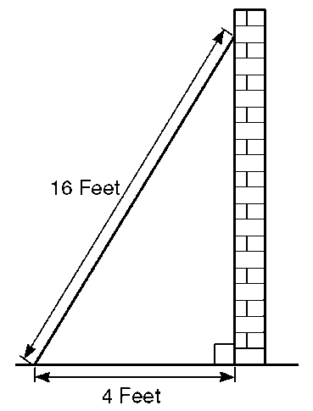
Sidney places the foot of his ladder on horizontal ground and the top against a vertical wall.

The ladder is 16 feet long.

The foot of the ladder is 4 feet from the base of the wall.

(i) Work out how high up the wall the ladder reaches. Give your answer to 3 significant figures.

(2)
(ii) Work out the angle the base of the ladder makes with the ground. Give your answer to 3 significant figures

(2)
Question 2

Given that cos Ɵ = $\frac{1}{3}$ and Ɵ is acute, find the exact value of tan Ɵ

(3)

Question 3

Sketch the graph of y = cos x for $0≤x≤360°$

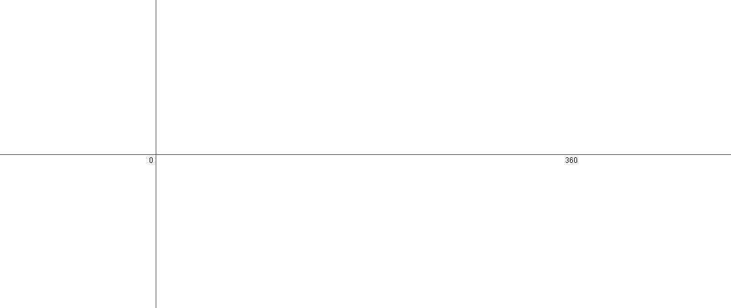 (3)

Total / 10
10 Sine / Cosine Rule

Question 1
For triangle ABC, calculate

(i) the length of BC

(3)
(ii) the area of triangle ABC

(3)

Question 2
The course for a yacht race is a triangle as shown in the diagram below. The yachts start at A, then travel to B, then to C and finally back to A.
Calculate the total length of the course for this race.
(4)

Total / 10

11 Inequalities

Question 1

Solve
- $x^{2 }-36 ≤0$

- $9x^{2}-25 ≥0$

- $3x^{2}+10x <0$
(3)

Question 2

Solve $\frac{21}{x+2}- \frac{5}{x+1}<4$

………………………
(4)

Question 3

Solve $3x^{2}-8>2x$

………………………
(3)

Total / 10

12 Algebraic proof

Question 1
- If n is a positive integer, write down expressions for the next two consecutive integers.

(1)
- Use algebra to prove that the sum of three positive consecutive integers is always a multiple of 3.

(3)

Question 2
Prove that the square of an odd number is also odd.

(3)

Question 3

Given that x is a positive integer, prove that $\frac{4x^{3}+20x}{2x^{2}+10}$ is always even.

(3)

Total / 10

13 Vectors

Question 1

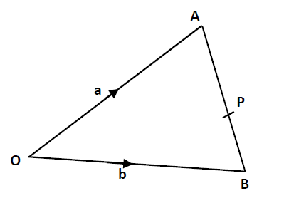
OAP is a triangle

2f + g

3h
Diagram NOT drawn accurately

OA = 2f + g and OB = 3h
P is the point on AB such that AP: PB = 2:1

(a) Find the vector BA in terms of f, g and h.

..............................................
(1)
(b) Find the vector PO in terms of f, g and h

..............................................
(2)

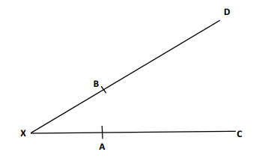
Diagram NOT drawn accurately
Diagram NOT drawn accurately
p
q
Question 2
B is the point on AD such that XB:BD is 1:2
A is the point on XC such that XA:XC is 1:2

XB = p and XA = q

Use vectors to explain the geometrical relationships between the line segments BA and DC.

(4)
Question 3
P
Q
R
S
j
k
Diagram NOT drawn accurately
A
M
PQRS is a parallelogram.
A is the point on PR such that PA:AR is 2:1
M is the midpoint of RS.

(b) Prove that Q, A and M are co-linear.

..............................................
(3)

Total / 10

14 Probability

Question 1

A box contains 3 new batteries, 5 partly used batteries and 4 dead batteries.
Kelly takes two batteries at random.
Work out the probability that she picks two different types of batteries.

..............................................
(3)

Question 2

Caleb either walks to school or travels by bus.
The probability that he walks to school is 0.75.
If he walks to school, the probability that he will be late is 0.3.
If he travels to school by bus, the probability that he will be late is 0.1.
Work out the probability that he will not be late.

..............................................
(3)

Question 3

The two way table shows the number of deaths and serious injuries caused by road traffic accidents in Great Britain in 2013.

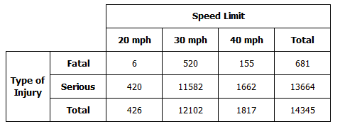

Work out an estimate for the probability:

- that the accident is serious.

............................................
(1)
(b) that the accident is fatal given that the speed limit is 30 mph.

............................................
(1)
(c) that the accident happens at 20 mph given that the accident is serious.

............................................
(2)

Total / 10

15 Statistics

Question 1

The histogram and the frequency table show some information about how much time vehicles spent in a car park.

Time, minutes |  |  | Frequency
0 | < x ≤ | 10
10 | < x ≤ | 30
30 | < x ≤ | 60 | 75
60 | < x ≤ | 80 | 24
 |  | Total | 150

- Use the information to complete the histogram
(2)
b) Use the histogram to find the missing frequencies in the table

……… …………………………
(2)

Question 2
The table shows the length of 678 phone calls made at a call centre

Time, secs |  |  | Frequency
0 | < x ≤ | 20 | 20
20 | < x ≤ | 60 | 148
60 | < x ≤ | 120 | 240
120 | < x ≤ | 300 | 270
 |  | Total | 678

a) Draw a fully labelled histogram to show the length of the phone calls.

(4)
b) Estimate the number of phone calls that lasted more than 4 minutes.

…………………………………
(2)

Total / 10

