## **Transition into L3 BTEC National Business**

[](http://www.google.co.uk/url?sa=i&rct=j&q=&esrc=s&source=images&cd=&cad=rja&uact=8&ved=0ahUKEwjGy5qcr_XMAhXlCcAKHWUkAJsQjRwIBw&url=http://www.contactvirginmedia.com/virgin-media-business/&bvm=bv.122676328,d.ZGg&psig=AFQjCNFQmLxFOUShGjpzpkP-N6CgKJrhWw&ust=1464270601727399)

[](http://www.google.co.uk/url?sa=i&rct=j&q=&esrc=s&source=images&cd=&cad=rja&uact=8&ved=0ahUKEwjRo_-Yo-jMAhVrDMAKHaG3C3IQjRwIBw&url=http://qualifications.pearson.com/en/qualifications/btec-nationals/business-2016.html&psig=AFQjCNHLZ53wmLi3ij3MXDAySyNqNzAnHg&ust=1463820697655223)

Getting ready for BTEC National Business

**A guide to the course to help you get ready for Business**

**Contents**

**Course Information**

**Course Expectations**

**Pre knowledge key terms**

**Recommendation reading list**

**Movie/ video clip recommendations**

**Website to research**

**Promotion of Business**

**Research of Colleges and 6th Form Schools**

**Research Tasks**

**Marketing Campaign Activity**

**Course Information**

**Course being studied**

**BTEC National Extended Certificate in Business**

**Units studied**

**Unit 1: Exploring Business (Internally assessed)**

**Unit 2: Developing a Marketing Campaign (Externally assessed)**

**Unit 3: Personal and Business Finance (Externally assessed)**

**These unit are mandatory and are required to complete the course. Unit 2 and unit 3 are externally assessed.**

**Additional unit required to complete the course**

**Unit 27: Work experience in Business**

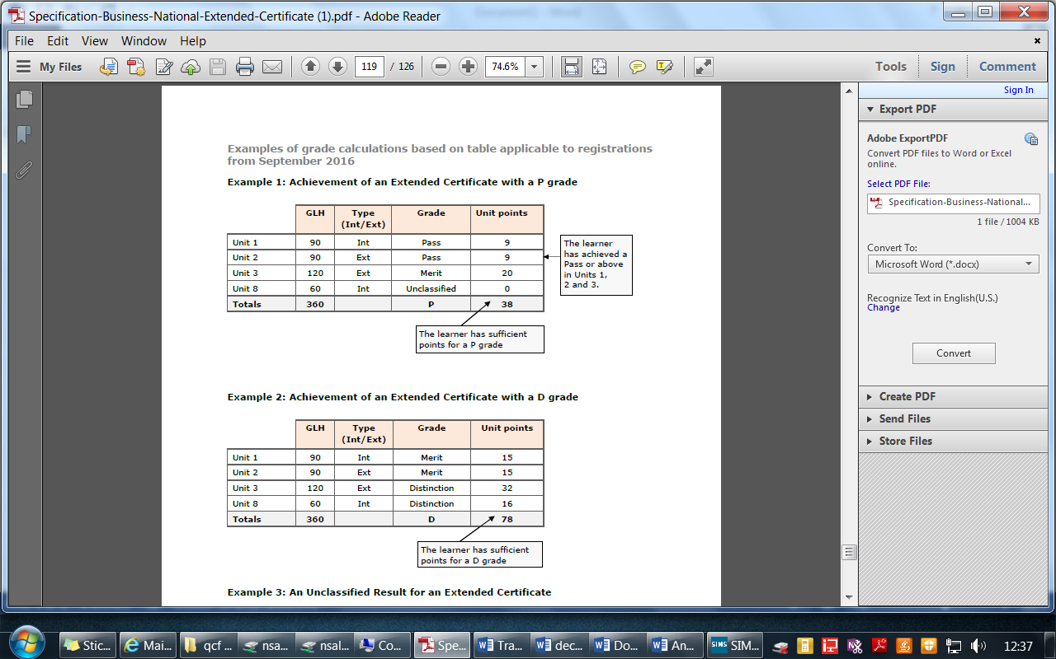**This requires the learner to undertake a period of work relating to the course**

**Grading criteria**

**The criteria for each unit varies between a pass to a distinction, a combination of grades can be achieved, and an example for a pass and Distinction is below.**

**Important information regarding mandatory units!**

**You must pass all the mandatory units at a pass or above to complete the course**

**Course Expectations**

* **100% attendance to lessons**
* **Excellent behaviour towards the learning environment**
* **Positive contributions to class discussions**
* **Participate in presentations and work as a team when required**

**Assessment Expectations**

**All learner work must be submitted on the given deadline day. If not the grade will be capped at pass level regardless of criteria.**

**All leaners work needs to have the name and assignment title in the header and page numbers in the footer.**

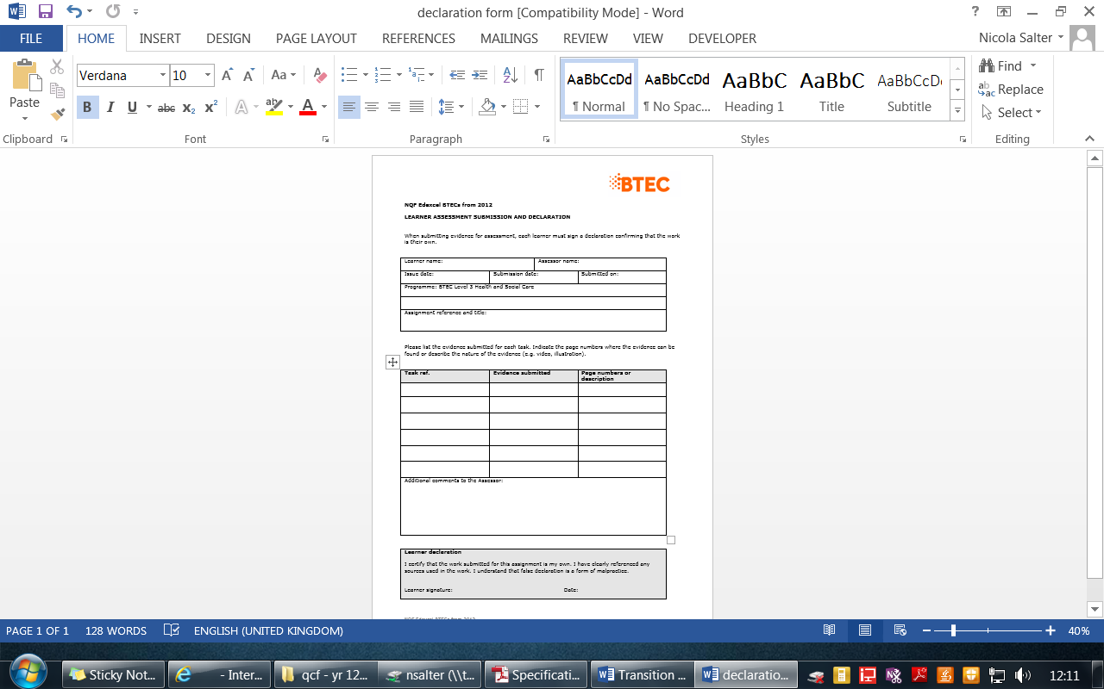**All learners need to have a submitted their work with a signed declaration form, this form states that is your own work!**

**Pre knowledge = Key terms you should understand**

**How to learn these key words**

Flash cards are a great way to learn the key words, write the command word on one side and the definition on the other. Practice by asking someone to test you.

Simple look, cover and test- practice the command word and definition and then write the definition on a blank piece of paper.

**Command or term Definition**

|  |  |
| --- | --- |
| *Command/ term* | *Definition* |
| **Primary research** | Research compiled directly from the original source, which may not have been compiled before. Learners are expected to understand the advantages and disadvantages of different primary research methods. |
| **Qualitative research** | Descriptive data, such as data drawn from open-ended questions in questionnaires, interviews or focus groups. |
| **Quantitative research** | Data in numerical form which can be categorised and used to construct graphs or tables of raw data. |
| **Secondary sources/research** | Published research reports and data, likely to be based on analysis of primary research. |

**Pre knowledge = Key terms you should understand**

|  |  |
| --- | --- |
| Command or term | Definition |
| **Assess** | Learners present a careful consideration of varied factors or events that apply to a specific situation or to identify those which are the most important or relevant and arrive at a conclusion. |
| **Calculate** | Learners work out an answer, usually by adding, multiplying, subtracting or dividing. Can involve the use of formula. |
| **Discuss** | Learners consider different aspects of:   * A theme or topic how they interrelate; * The extent to which they are important.   A conclusion is not required. |
| **Evaluate** | Learners’ work draws on varied information, themes or concepts to consider aspects  such as:  • strengths or weaknesses  • advantages or disadvantages;  • alternative actions  • Relevance or significance.  Learners’ inquiries should lead to a supported judgement showing relationship to its context.  This will often be in a conclusion. Evidence will be written. |
| **Explain** | Learners’ work shows clear details and gives reasons and/or evidence to support an opinion, view or argument. It could show how conclusions are drawn (arrived at). Learners are able to show that they comprehend the origins, functions and objectives of a subject, and its suitability for purpose. |
| **Give** | Learners can provide:  • examples  • Justifications. |
| **Identify** | Learners indicate the main features or purpose of something by recognising it and/or being able to discern and understand facts or qualities. |
| **Illustrate** | Learners include examples, images or diagrams to show what is meant in a specific context. |
| **Outline** | Learners’ work, performance or practice gives a summary or overview or a brief description of something. |

**Recommendation reading list**

Brammer J, Cox D, Fardon M and Penning A – *Active Accounting* (Osborne Books, 2002) ISBN 1872962378

Dyson J R – *Accounting for Non-Accounting Students* (FT Prentice Hall, 2007) ISBN 0273709224

Foden, s., et al, 2008. *AQA AS Business Studies*. Cheltenham: Nelson Thornes Ltd. (ISBN 978-0-7487-9846-9)

Coupland-Smith, H., et al, 2009. *AQA A2 Business Studies*. Cheltenham: Nelson Thornes Ltd. (ISBN 978-0-7487-9847-6)

Wolinski, J. & Coates, G., 2008. A2 2nd Edition, AQA Business Studies. Oxford: Philip Allan. (ISBN 978-0-340-95935-0)

Wolinski, J. & Coates, G., 2009. A2 2nd Edition, AQA Business Studies. Oxford: Philip Allan. (ISBN 978-0-340-95934-3)

CGP, AS/A2 Level Business Studies AQA Complete Revision & Practice

Brammer J, Cox D, Fardon M and Penning A – *Active Accounting* (Osborne Books, 2002) ISBN 1872962378

Cox D and Street D – *Limited Company Accounts* (IAS) (Osborne Books, 2005) ISBN 1872962939

Dyson J R – *Accounting for non-Accounting Students* (Prentice Hall, 2007) ISBN 027370922

**Journals**

*Accountancy* (CCH)

*Accountancy Age* (VNU Business Publications)

*Accounting Technician* (Centurion Publishing Group)

*PQ Magazine* (PQ Publishing)

**Movie/ Video Clip recommendations**

The following programmes often feature business items:

*The Money Programme*, BBC2 (weekly)

*Working Lunch*, BBC2 (daily)

<https://www.youtube.com/watch?v=i1xz5Kv-7VY>

In 30 words what is marketing?

**The pursuit of happiness**

Did you find this film inspirational?

**Website to research**

Unit 1: Exploring Business (Internally assessed)

www.adassoc.org.uk The Advertising Association

www.amazon.com Amazon – online shopping

www.asa.org.uk The Advertising Standards Authority

www.bized.ac.uk Business education website including learning materials and quizzes

www.cadburys.co.uk Cadbury Trebor Bassett

www.cim.co.uk The Chartered Institute of Marketing

www.easyjet.com easyJet main website

www.marketingteacher.com Free marketing resources for learners, teachers and professionals

www.statistics.gov.uk Official UK statistics

www.swatch.com Main website for Swatch

www.tesco.com Main website for Tesco

Unit 2: Developing a Marketing Campaign (Externally assessed)

www.accountingtechnician.co.uk Association of Accounting Technicians Online

www.accountingweb.co.uk Accounting Web – for news and analysis

news.bbc.co.uk/1/hi/business The business pages of the BBC website

www.bized.co.uk A business education resource site

www.canterbury.gov.uk An example of a specific local business support website

www.thetimes100.co.uk The Times 100 case studies

www.tutor2u.net/business/accounts Support for teachers and learners

www.tutor2u.co.uk/business

Unit 3: Personal and Business Finance (Externally assessed)

www.aat.org.uk The Association of Accounting Technicians

www.accountingtechnician.co.uk Association of Accounting Technicians Online

news.bbc.co.uk/1/hi/business/default.stm The business pages of the BBC website

www.bized.co.uk A business education resource site

www.canterbury.gov.uk An example of a specific local business support website

www.frc.org.uk/asb The Accounting Standards Board, part of the Financial Reporting

Council, with information about accounting standards

www.iasb.org The International Accounting Standards Board, with information about the new international accounting standards

www.thetimes100.co.uk The Times 100 case studies

**How do you promote a Business?**

Identify how companies promote their Businesses

**Research 3 colleges and 3 6th form schools**

You need to research 3 colleges and 3 6th form schools, gathering information on how they market their courses for Post 16 studies.

Consider the following:

* Prospectus
* Courses they offer
* Information on the website

# College/ 6th form ………………………………………………………………………………………

# College/ 6th form ………………………………………………………………………………………

# College/ 6th form ………………………………………………………………………………………

# College/ 6th form ………………………………………………………………………………………

# College/ 6th form ………………………………………………………………………………………

# College/ 6th form ………………………………………………………………………………………

**Using your research answer the following questions**

**How is the course information displayed?**

**How do they get their information to parents and pupils in real-time?**

**How would you rate their prospectus? 1 poor to 5 excellent**

|  |  |  |
| --- | --- | --- |
| **College/ 6th form** | **Grade** | **Why?** |
|  |  |  |
|  |  |  |
|  |  |  |
|  |  |  |
|  |  |  |
|  |  |  |

Cash Flow

Reading the information below you need to understand what a cash flow forecast is and how important they are in business

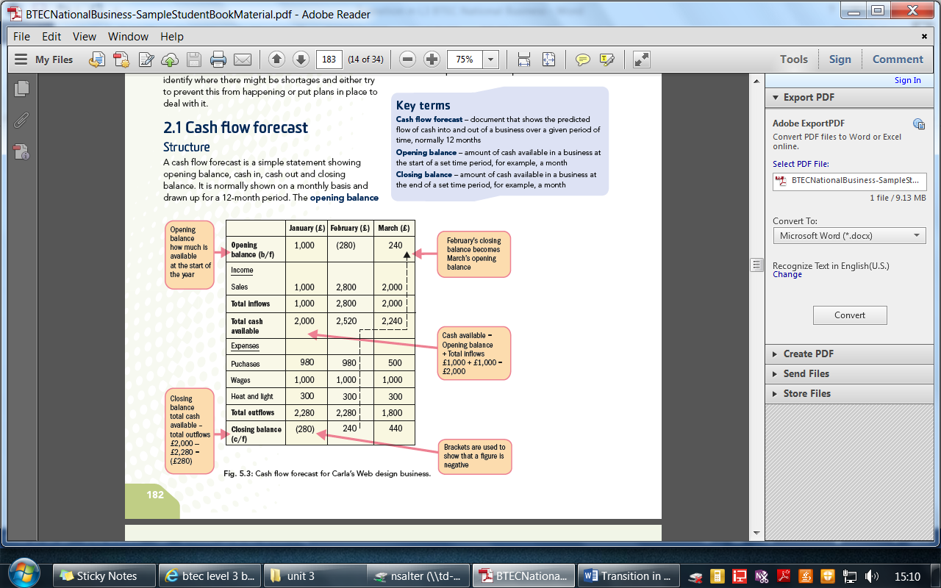

Personal cash flow

**Draw a cash flow table** to show your personal finances for the next month. You should think about what money will be coming in from wages, presents, parents and so on as appropriate, and also what expenses you will have. These might include food and drink, presents, trips, travel and so on.

1. What is your opening balance at the start of the month?
2. What is your closing balance at the end of the month?
3. Are there any points during the month where you may have a cash flow problem?
4. What actions can you take to ensure that any cash flow problems are solved

Lily’s cleaning services

Lily is setting up a small business providing cleaning services to offices on a trading estate in Scarborough. She has asked you to help her prepare a cash flow forecast for her first 12 months of trading.

You should produce a forecast from January to December based on the information provided below:

Sales and purchases for the 12 months are expected to be as follows.

Month Sales Purchases

January £5,000 £600

February £5,000 £600

March £5,000 £600

April £5,000 £600

May £5,000 £600

June £5,000 £600

July £4,000 £500

August £4,000 £500

September £5,000 £600

October £6,000 £650

November £6,000 £650

December £6,000 £650

At the beginning of January she will buy two small cars, to drive herself and staff to the offices, each costing £10,000. She will invest £15,000 of her own money and has agreed a bank loan of £7,000.

Lily will receive the loan in January and start repayments the following month at a fixed rate of £250 per month. When meeting with her bank manager, she also agreed a business overdraft that will be charged at a rate of one per cent on any negative closing balances.

In order to start trading in January, she buys £4,000 worth of cleaning equipment, including vacuum cleaners and floor buffers. In addition, she spends £150 on less durable (long-lasting) products such as dusters and mops, which she plans to replace every second month.

Lily plans to offer 30 days’ credit terms to two of her bigger cleaning contracts. These two combined will account for £2,200 of her monthly sales.

Lily has rented a small lock-up to store her equipment and materials in at a cost of £600 per month. She will employ four cleaners each earning £400 per month and a cleaning supervisor earning an annual salary of £7,200. She will withdraw £1,000 a month for herself, and hopes to be able to increase this to £1,200 per month after six months.

Additional monthly costs include:

• £300 car insurance

• £20 advertising

• £100 fuel.

1. Use a spreadsheet to produce a 12-month cash flow forecast for Lily.
2. Identify and explain any potential cash flow problems she may face.

3. Do you think Lily was right to offer her two biggest customers 30 days’ credit? Justify your answer.

**Marketing Campaign:**

**The Dukeries 6th form**

**Create 10 ideas how you would promote the 6th form**

**1**

**2**

**3**

**4**

**5**

**6**

**7**

**8**

**9**

**10**

Now consider your ideas in stages, short, medium and long term goals. Order your ideas, starting with the short term goals.

Short term goals (4 needed)

Medium term goals (4 needed)

Long term goals (4 needed)

What do you think would be the best possible method to send information to pupils and parents (you need to make it creative and interesting?)

*Now create SMART Goals for your idea’s*

**What’s SMART?**

Good targets need to be:

* Specific
* Measurable
* Achievable
* Realistic/relevant
* Timed

**S is for Specific** “Specific” means that you have to say what you want to do, very clearly.

**M is for Measurable** Measurable targets tell you exactly what you need to do to succeed.

**A is for Achievable**An achievable target has to be something you can do

**R is for Realistic/ relevant** What I’m going to do needs to help me to get what I want.

**A is for Timed** If I don’t know how much time I have, I don’t know when to take action.

How hard do I have to train?

When does my work have to be completed?

Short term goal

|  |  |
| --- | --- |
| SMART |  |
| S |  |
| M |  |
| A |  |
| R |  |
| T |  |

Medium term goal

|  |  |
| --- | --- |
| SMART |  |
| S |  |
| M |  |
| A |  |
| R |  |
| T |  |

Long term goal

|  |  |
| --- | --- |
| SMART |  |
| S |  |
| M |  |
| A |  |
| R |  |
| T |  |

**Now create a 5 minute presentation of your ideas of how to promote the Dukeries Academy 6th form, you will be assessed on this presentation**

You can use PowerPoint, VLOG, VINE, Short video etc.

*The assessment criteria below highlights how you will be assessed for your………………………*

Pass level Marketing campaign

* Outline marketing techniques used by other post 16 institution
* Produce a marketing strategy for 6th form that identifies the selling points of the Dukeries 6th form and the target audience
* Review the success of a marketing campaign identifying successes and areas for improvement

Merit level marketing campaign

* Explain marketing techniques used post 16 institution and how they would help the Dukeries 6th form
* Describes the selling points and the target audience of the Dukeries 6th form and how they can be used within your marketing campaign
* Review the success of a marketing campaign describing successes and areas for improvement.

Distinction level marketing campaign

* Analyse marketing techniques used by 6th form institution and the impact they could have on your marketing campaign
* Review the success of a marketing campaign analysing successes and areas