2 June 2020
Dear parent/carer

Re: Year 10 and Year 12 Assessments for 2020

I hope that you and your families are well and have managed to spend some quality time together over the half term.

Following Mr Rae’s letter of 1 June 2020, I am writing to inform you of how we intend to assess the progress of students in Year 10 and Year 12 during the summer term.

We would typically have had examinations for both year groups at this point in the academic year. These examinations would then be used by teachers to inform the planning of the next academic year. The results from these assessments are also used to inform UCAS predicted grades for Year 12 students.

These assessments are now more important than ever. Our staff need to assess the impact of Home Learning, so that we can best prepare for academic year 2020-21, and ensure that the outcomes our young people achieve continue to be the best in the local area. We also need to identify any gaps in knowledge, understanding and skills to ensure that these are addressed.

In order to achieve this, in the week beginning 22 June 2020, teachers of Year 10 and Year 12 will be setting students assessments to be completed. These assessments will take place in all GCSE and A Level subjects. Although the Academy may be partially re-opened to these year groups, we intend for these assessments to be completed as part of Home Learning.

It is essential that students take these assessments seriously. Whilst we cannot ensure exam conditions, it is crucial that students observe these as much as possible.

I would recommend that students do the following when completing each assessment:

- Turn off electronic devices (that are not used as part of the assessment e.g. calculators)
- Where possible complete these in a quiet space separate from other members of the household
- Only use the prescribed equipment when completing the assessment.

Each teacher will set a deadline for these assessments to be returned to them for marking and appropriate feedback. I will provide further guidance, in due course, on the format of these assessments, how they will be set and how they should be returned to the Academy.

Finally, I would like to take this opportunity to say thank you for your continued support. Please continue to follow our Home Learning Timetables, as we move to the next phase of this journey.

Please feel free to contact me if you wish to discuss any aspect of this letter.

Yours sincerely

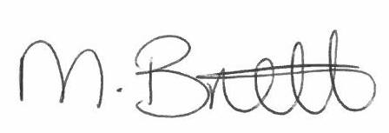

Mr Mike Brett
Assistant Principal

