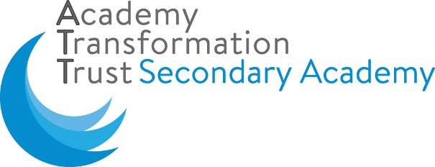

1 June 2020

Dear parent/carer

**Update: provision for Year 10 and Year 12 students**

I am writing to provide a further update following my letter of Friday 22 May 2020. You are aware that the government announced an aspiration for pupils in Year 10 and Year 12 to return to the Academy for ‘some face-to-face contact’ to supplement their Home Learning in the summer term. The Department for Education released the guidance to support this during half term. There are currently no plans for students in other year groups to return to the Academy before September 2020. Our current Home Learning provision will therefore continue for all students.

I am working with leaders in the Academy and at the Academy Transformation Trust to further refine our plans in response to this latest guidance. In line with the Prime Minister’s announcement on Sunday 24 May 2020 the earliest date Year 10 and Year 12 students will attend the Academy will now be **Monday 15 June 2020**; a week later than stated in my letter of 22 May. The health, safety and well-being of our students and staff will continue to underpin the plans we make. I can assure you that we will only further re-open The Dukeries Academy when I am satisfied that we can, as far as possible, minimise risk.

I will write to you to confirm our arrangements as soon as they have been finalised. I appreciate your patience in this matter as we continue our safe, steady and gradual response to this crisis.

If you have not already done so, I would be grateful if you could complete the form at the link below to help inform our planning. I have also sent the link to Year 10 and Year 12 parents and carers as a text message.

<https://forms.office.com/Pages/ResponsePage.aspx?id=eBpyvmw9NUqUimgWHu2ZKu1XVc--lQNOuo8eNVJze1dUQjRBQjk4RjI1OUdHTUJPVEgwWUQxSUc4Ty4u>

**Please be aware that attendance for vulnerable children and those of key workers are not affected by these changes.**

Please do not hesitate in contacting the Academy if you wish to discuss any aspect of the information contained in this letter.

Yours sincerely

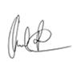

Mr Ged Rae

**Principal**

The Dukeries Academy, Whinney Lane, Newark, Notts, NG22 9TD

**T**: 01623 860545 **F**: 01623 836082 **E**: office@dukeries.attrust.org.uk **W**: www.dukeries.attrust.org.uk